Dear Travel Partner,
Greetings from SHAH TOUR, Darjeeling!
Are you planning to spend your vacations in the clear waters and beaches of Andaman & Nicobar Islands? Or do you want to savor the beauty of the mystic Havelock? Do you want to make the experience of travelling in Andamans not just memorable but secure and comfortable for your family and friends? Then you are in the right place. Shah Tour has been serving its customers for nearly two decades with incessant dedication. We understand the needs of our customers and the value of their hard earned money. Therefore, we never tend to compromise the services provided to our customers. Our trained, experienced and hospitable staff will make sure that your experience of vacation is comfortable, secure and memorable. Shah Tour specializes in customized and fixed departure holiday options for Andaman & Nicobar Islands, Sikkim, Darjeeling, Dooars and Bhutan. We provide car rental services, air, bookings, hotel bookings and other travel-related services at a reasonable price. Our excellent contacts with all major hotels and airlines make it easier for us to provide desired services. Our holiday packages are designed keeping in mind the general requirements of our customers. However, we also have a plan of flexible and personalized packages for them. You tell us the destination and we will make a personalized package for you. All this in an affordable price. We have managed not only to serve but excellently serve our customers.
Find package for Andaman & Nicobar Island (given below) valid from 01st APRIL TO 15TH JULY 2024
PACKAGE IS NON COMMISSIONABLE AND NET
OFFICES AT: DARJEELING, SILIGURI, & GANGTOK
Thanks & Regards
Ajay Shah / Abhay Shah
Shah Tour and Travels
B - 56, Satellite Township, ,Dabgram, Siliguri. 734015,
Ph- 0353 – 2541500 ,2542500 , Mob: 9932031500 ,9434131500 .
Contact us for : Domestic & International Air Tickets / Hotel Reservation / Car Rental .
Domestic and International / Packages / LTC Packages.
21 YEARS OF EXCELLENCE IN ALL TRAVEL RELATED SERVICES.
Our Motto is to develop, maintain trust & achieve sustainable development......

STTA 01 (3 Nights/ 4 Days)
ANDAMAN PARADISE (Port Blair 3N)
Day 01: Arrival Port Blair + Half Day Local SS (Local Sightseeing point closed on Monday & on all Govt. holidays)
You arrive to Port Blair, our escorts in the airport pick receive you there and then after a short introduction will take you to your first booked hotel, after check-in and once you are done with you lunch & refreshment, we will take a tour to the historic cellular jail which will be followed by the light and sound show. (the history & migration to these archipelago revolves around this monumental architecture , once you finish taking the tour just after a gap of half an hour , you will witness the light & sound show , like any other light & sound it’s a narration of the story of the jail through light & sound ) day end here back to the hotel.
Day 02: Excursion North Bay (Coral Island), Ross Island & Back (Carry Changing Cloth, water & dry food)
(closed on Wednesday) After breakfast we will set out on a Sea Safari, we will reach the water sports complex from here we will take a luxury motor sail and explore the famous islands of North Bay coral island & the historic Ross Island, experience the fun of cruising and feel the joy of sailing through small big Island and discover the blue ocean and with the on board crew and activity experts who will there to assist you. Upon arrival back to the Port our escorts will arrange necessary transfers back to the respective hotel.
Day 03: Excursion Havelock Island & Back
After breakfast at the Hotel and as per ferry timing (6:45 am to 01:30 pm any time in between) transfer to Jetty to take the onward ferry to Havelock Island. On arrival at Havelock Island, our representative will receive and escort you to the Radhanagar Beach, one of the most picturesque beaches on the Islands. The beach has also been ranked 07th among the beaches of Asia by the TIME magazine. Post lunch as per the ferry timing return back to Port Blair.
Day 04: Departure from Port Blair
Morning free for packing & personal activities, on time 08:00am check out from the hotel & on time transfer to Airport. Tour Ends
TOUR COST PER PERSON IN RUPEES
COST PER PERSON ON CP | 02 PAX | 04 PAX | 06 PAX | EXTRA BED | CHILD WITHOUT BED
STANDARD | 14300 | 12540 | 11990 | 8360 | 7260
DELUXE | 15950 | 14190 | 13420 | 9130 | 8140
SUPERIOR | 19140 | 17380 | 16720 | 10890 | 9130
LUXURY | 23320 | 21450 | 20900 | 13420 | 10230
PREMIUM | 27000 | 25300 | 24750 | 15620 | 11660

MEAL SUPPLEMENT PER PERSON
MEAL SUPPLEMENT (NON COMMISSIONABLE) | PER MEAL PER PAX + 5% GST
STANDARD | 350 + 5% GST
DELUXE | 450 + 5% GST
SUPERIOR | 550 + 5% GST
LUXURY | 750 + 5% GST
PREMIUM | 850 + 5% GST

HOTELS USED IN THE PACKAGE
DESTINATION | STANDARD | DELUXE | SUPERIOR | LUXURY | PREMIUM
PORT BLAIR | HOTEL SHREESH / SIMILAR | J HOTEL / SIMILAR | TSG EMERALD VIEW / SIMILAR | PEERLESS RESORT / SIMILAR | SYMPHONY SAMUNDRA / SIMILAR

VEHICLE USED IN THE PACKAGE
A/C Scorpio / Xylo (only 02 - 06 heads are allowed including child)

COST INCLUDES | COST EXCLUDES
- Accommodation in Twin Sharing in above mentioned hotels (base category rooms)  - Meals as mentioned above  - A/C car for all transfers and sightseeing (vehicle is not at disposal – only point to point)  - Entrance fee at Port Blair SS  - Boat Charge (Luxury Boat – Green Ocean or Makruzz – base category) for Havelock Island  - NAC Boat Tickets for Ross Island & North Bay Island | - Air Fare  - Personal Expenses  - Item that are not mentioned in the inclusions  - 5% Govt. service tax  - Guides & any Sports activities charges during sightseeing

STA 02 (3 Nights/ 4 Days)
EXPLORE ANDAMAN (Port Blair 2N + Havelock 1N)
Day 01: Arrival Port Blair + Half Day Local SS (Local Sightseeing point closed on Monday & on all Govt. holidays)
You arrive to Port Blair, our escorts in the airport pick receive you there and then after a short introduction will take you to your first booked hotel, after check-in and once you are done with you lunch & refreshment, we will take a tour to the historic cellular jail which will be followed by the light and sound show. (the history & migration to these archipelago revolves around this monumental architecture , once you finish taking the tour just after a gap of half an hour , you will witness the light & sound show , like any other light & sound it’s a narration of the story of the jail through light & sound ) day end here back to the hotel.
Day 02: Port Blair to Havelock Island
We start the day a bit early today as we need to embark for Havelock Island , the cruise depart (6:45 am to 01:30 pm any time in between).We have to report an hour early . Take a quick breakfast and head to Havelock Island the total journey time is around 1 and 1/2 hour by sea. Again once to reach in the island meet our escorts who will be standing outside the harbor restricted area with a name tag. Along with them proceed to your respective hotel and then plan you day, probably post lunch for Radhanagar beach. You can enjoy the beach as well as the sun set, which is the best you can see.
(Boat transfers are subjected to change as per the availability of tickets and weather conditions).
Day 03: Havelock Island to Port Blair
After check out at 9am. Spend the Morning at tour to Kalapathar Beach. The beach gets its name from the surrounding village, which isKalapathar Village and the black rocks. Later transfer to Havelock Jetty to take the return ferry to Port Blair as per ferry timing. Upon return from Havelock Island, transfer to Hotel. Stay Overnight at respective Hotel / Resort at Port Blair.
(Boat transfers are subjected to change as per the availability of tickets and weather conditions).
Day 04: Departure from Port Blair
Morning free for packing & personal activities, on time 08:00am check out from the hotel & on time transfer to Airport. Tour Ends.
TOUR COST PER PERSON IN RUPEES
COST PER PERSON ON CP | 02 PAX | 04 PAX | 06 PAX | EXTRA BED | CHILD WITHOUT BED
STANDARD | 12980 | 11220 | 10670 | 6930 | 5830
DELUXE | 14630 | 12760 | 12210 | 8360 | 6600
SUPERIOR | 18150 | 16390 | 15840 | 10230 | 8030
LUXURY | 21450 | 19690 | 19140 | 12760 | 9460
PREMIUM | 26620 | 24860 | 24310 | 16390 | 11990
MEAL SUPPLEMENT PER PERSON
MEAL SUPPLEMENT (NON COMMISSIONABLE) | PER MEAL PER PAX + 5% GST
STANDARD | 350 + 5% GST
DELUXE | 450 + 5% GST
SUPERIOR | 550 + 5% GST
LUXURY | 750 + 5% GST
PREMIUM | 850 + 5% GST

HOTELS USED IN THE PACKAGE
DESTINATION | STANDARD | DELUXE | SUPERIOR | LUXURY | PREMIUM
PORT BLAIR | HOTEL SHREESH / SIMILAR | J HOTEL / SIMILAR | TSG EMERALD VIEW / SIMILAR | PEERLESS RESORT / SIMILAR | SYMPHONY SAMUNDRA / SIMILAR
HAVELOCK | GOLD STAR BEACH RESORT / SIMILAR | ELDORADO BEACH RESORT / SIMILAR | TSG BLUE RESORT / SIMILAR | SYMPHONY PALMS RESORT / SIMILAR | SILVER SAND BEACH RESORT / SIMILAR

VEHICLE USED IN THE PACKAGE
A/C Scorpio / Xylo (only 02 - 06 heads are allowed including child)

COST INCLUDES | COST EXCLUDES
- Accommodation in Twin Sharing in above mentioned hotels (base category rooms)  - Meals as mentioned above  - A/C car for all transfers and sightseeing (vehicle is not at disposal – only point to point)  - Entrance fee at Port Blair SS  - Boat Charge (Luxury Boat – Green Ocean or Makruzz – base category) for Havelock Island  - NAC Boat Tickets for Ross Island & North Bay Island | - Air Fare  - Personal Expenses  - Item that are not mentioned in the inclusions  - 5% Govt. service tax  - Guides & any Sports activities charges during sightseeing

STA 03 (4 Nights/ 5 Days)
UNIQUE ANDAMAN (Port Blair 3N + Havelock 1N)
Day 01: Arrival Port Blair + Half Day Local SS (Local Sightseeing point closed on Monday & on all Govt. holidays)
You arrive to Port Blair, our escorts in the airport pick receive you there and then after a short introduction will take you to your first booked hotel, after check-in and once you are done with you lunch & refreshment, we will take a tour to the historic cellular jail which will be followed by the light and sound show. (the history & migration to these archipelago revolves around this monumental architecture , once you finish taking the tour just after a gap of half an hour , you will witness the light & sound show , like any other light & sound it’s a narration of the story of the jail through light & sound ) day end here back to the hotel.
Day 02: Excursion North Bay (Coral Island), Ross Island & Back (Carry Changing Cloth, water & dry food)
(closed on Wednesday ) After breakfast we will set out on a Sea Safari, we will reach the water sports complex from here we will take a luxury motor sail and explore the famous islands of North Bay coral island & the historic Ross Island, experience the fun of cruising and feel the joy of sailing through small big Island and discover the blue ocean and with the on board crew and activity experts who will there to assist you. Upon arrival back to the Port our escorts will arrange necessary transfers back to the respective hotel.
Day 03: Port Blair to Havelock Island
We start the day a bit early today as we need to embark for Havelock Island ,the cruise depart (6:45 am to 01:30 pm any time in between). So we have to report an hour early . Take a quick breakfast and head to Havelock Island the total journey time is around 1 and 1/2 hour by sea. Again once to reach in the island meet our escorts who will be standing outside the harbor restricted area with a name tag. Along with them proceed to your respective hotel and then plan you day, probably post lunch for Radhanagar beach. You can enjoy the beach as well as the sun set, which i guess is the best you can see. (Boat transfers are subjected to change as per the availability of tickets and weather conditions).
Day 04: Havelock Island to Port Blair
After check out at 9am. Spend the Morning at tour to Kalapathar Beach. The beach gets its name from the surrounding village, which isKalapathar Village and the black rocks. Later transfer to Havelock Jetty to take the return ferry to Port Blair as per ferry timing. Upon return from Havelock Island, transfer to Hotel. Stay Overnight at respective Hotel / Resort at Port Blair. (Boat transfers are subjected to change as per the availability of tickets and weather conditions).
Day 05: Departure from Port Blair
Morning free for packing & personal activities, on time 08:00am check out from the hotel & on time transfer to Airport. Tour Ends.

TOUR COST PER PERSON IN RUPEES
COST PER PERSON ON CP | 02 PAX | 04 PAX | 06 PAX | EXTRA BED | CHILD WITHOUT BED
STANDARD | 17050 | 14850 | 14080 | 9350 | 7920
DELUXE | 19250 | 17050 | 16280 | 11330 | 9020
SUPERIOR | 23760 | 21670 | 20790 | 13750 | 10780
LUXURY | 28600 | 26400 | 25520 | 17160 | 12650
PREMIUM | 35090 | 32780 | 32010 | 21120 | 16060

MEAL SUPPLEMENT PER PERSON
MEAL SUPPLEMENT (NON COMMISSIONABLE) | PER MEAL PER PAX + 5% GST
STANDARD | 350 + 5% GST
DELUXE | 450 + 5% GST
SUPERIOR | 550 + 5% GST
LUXURY | 750 + 5% GST
PREMIUM | 850 + 5% GST

HOTELS USED IN THE PACKAGE
DESTINATION | STANDARD | DELUXE | SUPERIOR | LUXURY | PREMIUM
PORT BLAIR | HOTEL SHREESH / SIMILAR | J HOTEL / SIMILAR | TSG EMERALD VIEW / SIMILAR | PEERLESS RESORT / SIMILAR | SYMPHONY SAMUNDRA / SIMILAR
HAVELOCK | GOLD STAR BEACH RESORT / SIMILAR | ELDORADO BEACH RESORT / SIMILAR | TSG BLUE RESORT / SIMILAR | SYMPHONY PALMS RESORT / SIMILAR | SILVER SAND BEACH RESORT / SIMILAR

VEHICLE USED IN THE PACKAGE
A/C Scorpio / Xylo (only 02 - 06 heads are allowed including child)

COST INCLUDES | COST EXCLUDES
- Accommodation in Twin Sharing in above mentioned hotels (base category rooms)  - Meals as mentioned above  - A/C car for all transfers and sightseeing (vehicle is not at disposal – only point to point)  - Entrance fee at Port Blair SS  - Boat Charge (Luxury Boat – Green Ocean or Makruzz – base category) for Havelock Island  - NAC Boat Tickets for Ross Island & North Bay Island | - Air Fare  - Personal Expenses  - Item that are not mentioned in the inclusions  - 5% Govt. service tax  - Guides & any Sports activities charges during sightseeing

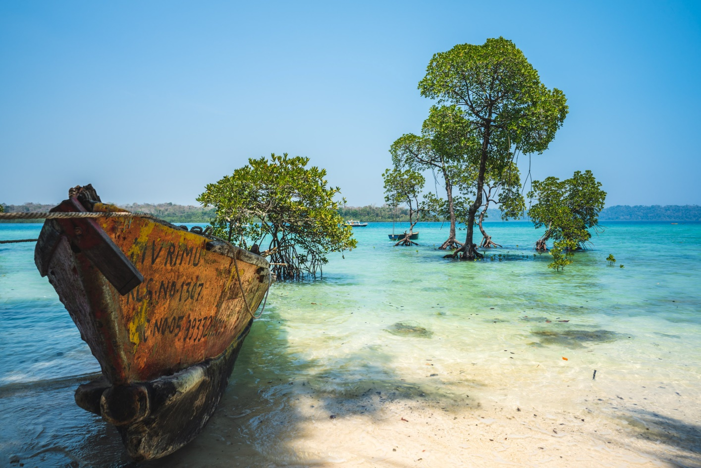

STA 04 (5 Nights/ 6 Days)
BEAUTIFUL ANDAMAN (Port Blair 3N + Havelock 2N)
Day 01: Arrival Port Blair + Half Day Local SS (Local Sightseeing point closed on Monday & on all Govt. holidays)
You arrive to Port Blair, our escorts in the airport pick receive you there and then after a short introduction will take you to your first booked hotel, after check-in and once you are done with you lunch & refreshment, we will take a tour to the historic cellular jail which will be followed by the light and sound show. (the history & migration to these archipelago revolves around this monumental architecture , once you finish taking the tour just after a gap of half an hour , you will witness the light & sound show , like any other light & sound it’s a narration of the story of the jail through light & sound ) day end here back to the hotel.
Day 02: Excursion North Bay (Coral Island), Ross Island & Back (Carry Changing Cloth, water & dry food)
(closed on Wednesday) After breakfast we will set out on a Sea Safari, we will reach the water sports complex from here we will take a luxury motor sail and explore the famous islands of North Bay coral island & the historic Ross Island, experience the fun of cruising and feel the joy of sailing through small big Island and discover the blue ocean and with the on board crew and activity experts who will there to assist you. Upon arrival back to the Port our escorts will arrange necessary transfers back to the respective hotel.
Day 03: Port Blair to Havelock Island
We start the day a bit early today as we need to embark for Havelock Island , the cruise depart at (6:45 am to 01:30 pm any time in between).So we have to report an hour early . Take a quick breakfast and head to Havelock Island the total journey time is around 1 and 1/2 hour by sea. Again once to reach in the island meet our escorts who will be standing outside the harbor restricted area with a name tag. Along with them proceed to your respective hotel and then plan you day, probably post lunch for Radhanagar beach. You can enjoy the beach as well as the sun set, which i guess is the best you can see. (Boat transfers are subjected to change as per the availability of tickets and weather conditions).
Day 04: In Havelock Island
After Breakfast visit to Elephant Beach By Motor Boat for Mesmerizing View of Corals and Enjoy Snorkeling (Boat will be on sharing basis). Overnight stay at Resort in Havelock.
Day 05: Havelock Island to Port Blair
After check out at 9am. Spend the Morning at tour to Kalapathar Beach. The beach gets its name from the surrounding village, which isKalapathar Village and the black rocks. Later transfer to Havelock Jetty to take the return ferry to Port Blair as per ferry timing. Upon return from Havelock Island, transfer to Hotel. Stay Overnight at respective Hotel/ Resort at Port Blair.
(Boat transfers are subjected to change as per the availability of tickets and weather conditions).
Day 06: Departure from Port Blair
Morning free for packing & personal activities, on time 08:00am check out from the hotel & on time transfer to Airport. Tour Ends

TOUR COST PER PERSON IN RUPEES
COST PER PERSON ON CP | 02 PAX | 04 PAX | 06 PAX | EXTRA BED | CHILD WITHOUT BED
STANDARD | 21450 | 18700 | 17710 | 11770 | 10010
DELUXE | 24420 | 21670 | 20680 | 14190 | 11220
SUPERIOR | 30470 | 27830 | 26840 | 17160 | 13640
LUXURY | 35750 | 33000 | 32010 | 21450 | 16060
PREMIUM | 44880 | 42020 | 41140 | 27390 | 20240

MEAL SUPPLEMENT PER PERSON
MEAL SUPPLEMENT (NON COMMISSIONABLE) | PER MEAL PER PAX + 5% GST
STANDARD | 350 + 5% GST
DELUXE | 450 + 5% GST
SUPERIOR | 550 + 5% GST
LUXURY | 750 + 5% GST
PREMIUM | 850 + 5% GST

HOTELS USED IN THE PACKAGE
DESTINATION | STANDARD | DELUXE | SUPERIOR | LUXURY | PREMIUM
PORT BLAIR | HOTEL SHREESH / SIMILAR | J HOTEL / SIMILAR | TSG EMERALD VIEW / SIMILAR | PEERLESS RESORT / SIMILAR | SYMPHONY SAMUNDRA / SIMILAR
HAVELOCK | GOLD STAR BEACH RESORT / SIMILAR | ELDORADO BEACH RESORT / SIMILAR | TSG BLUE RESORT / SIMILAR | SYMPHONY PALMS RESORT / SIMILAR | SILVER SAND BEACH RESORT / SIMILAR

VEHICLE USED IN THE PACKAGE
A/C Scorpio / Xylo (only 02 - 06 heads are allowed including child)

COST INCLUDES | COST EXCLUDES
- Accommodation in Twin Sharing in above mentioned hotels (base category rooms)  - Meals as mentioned above  - A/C car for all transfers and sightseeing (vehicle is not at disposal – only point to point)  - Entrance fee at Port Blair SS  - Boat Charge (Luxury Boat – Green Ocean or Makruzz – base category) for Havelock Island  - NAC Boat Tickets for Ross Island & North Bay Island  - Fiber Boat for Elephant island visit by Sharing | - Air Fare  - Personal Expenses  - Item that are not mentioned in the inclusions  - 5% Govt. service tax  - Guides & any Sports activities charges during sightseeing

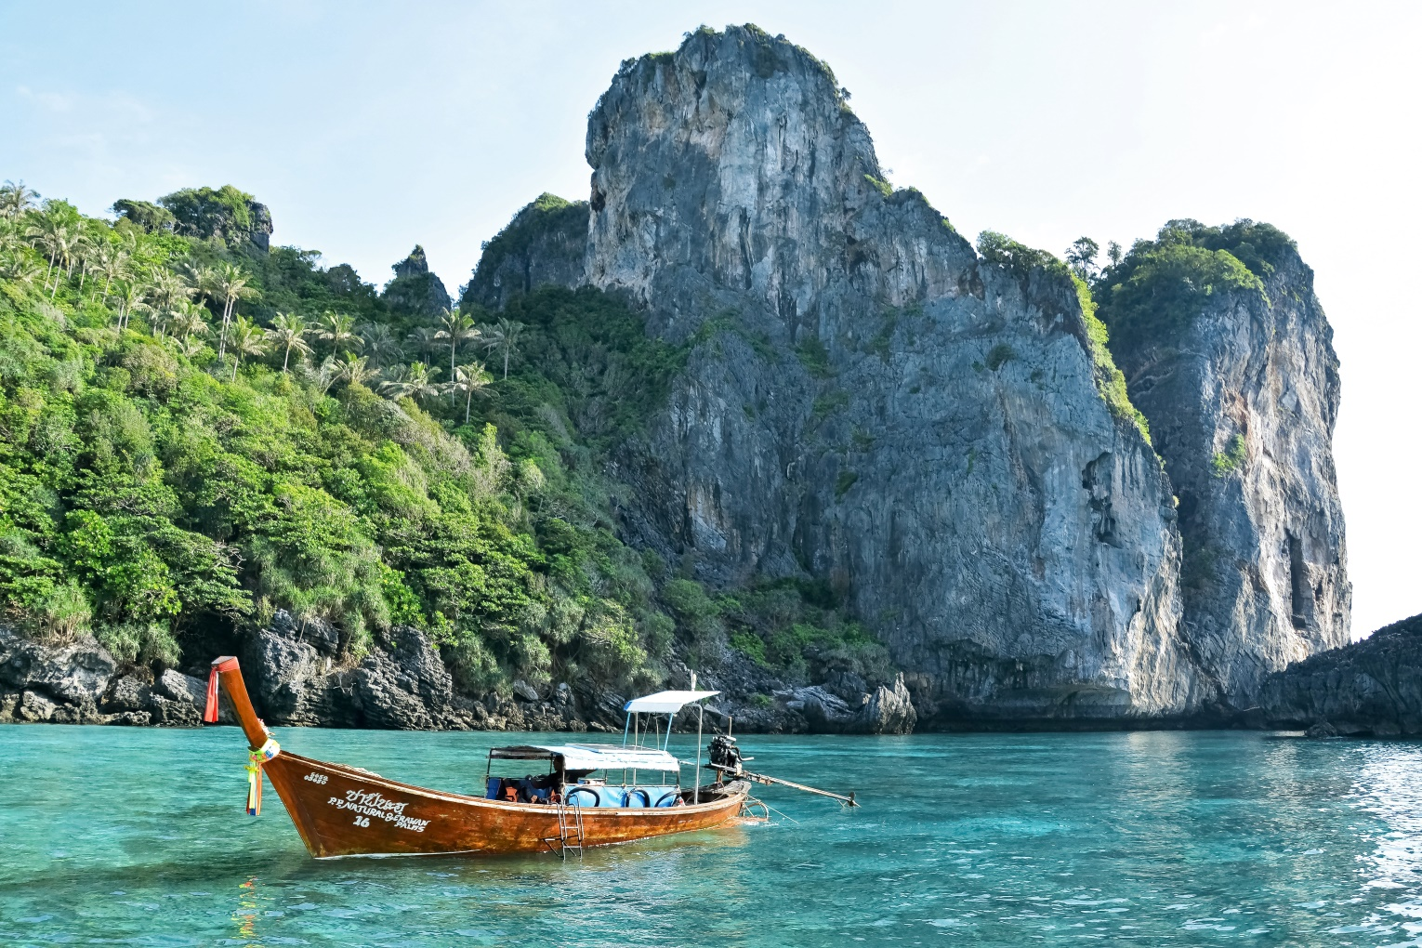
STA 05 (5 Nights/ 6 Days)
BEST OF ANDAMAN (Port Blair 2N + Havelock 2N + Neil Island 1N)
Day 01: Arrival Port Blair + Half Day Local SS (Local Sightseeing point closed on Monday & on all Govt. holidays)
You arrive to Port Blair, our escorts in the airport pick receive you there and then after a short introduction will take you to your first booked hotel, after check-in and once you are done with you lunch & refreshment, we will take a tour to the historic cellular jail which will be followed by the light and sound show. (the history & migration to these archipelago revolves around this monumental architecture , once you finish taking the tour just after a gap of half an hour , you will witness the light & sound show , like any other light & sound it’s a narration of the story of the jail through light & sound ) day end here back to the hotel.
Day 02: Port Blair to Havelock Island
We start the day bits early today as we need to embark for Havelock Island, the cruise depart at (6:45 am to 01:30 pm any time in between). So we have to report an hour early. Take a quick breakfast and head to Havelock Island the total journey time is around 1 and 1/2 hour by sea. Again once to reach in the island meet our escorts who will be standing outside the harbor restricted area with a name tag. Along with them proceed to your respective hotel and then plan you day, probably post lunch for Radhanagar beach. You can enjoy the beach as well as the sun set, which i guess is the best you can see. (Boat transfers are subjected to change as per the availability of tickets and weather conditions).
Day 03: In Havelock Island
After Breakfast visit to Elephant Beach by Motor Boat for Mesmerizing View of Corals and Enjoy Snorkeling (Boat will be on sharing basis). Overnight stay at Resort in Havelock.
Day 04: Havelock Island to Neil Island
We will check-out the resort as per the schedule timing which is generally in the morning 0900 hours. And then proceed to board the cruise back to Neil Island. Once you arrive in Neil you will meet our escorts outside the exit area, check-in to hotel, finish lunch and then precede to an excursion to Island visit all the beaches around the Island, night stay in Neil Island. (While leaving from Port Blair to Havelock island probably you can leave your bigger luggage in port Blair , hotels in Port Blair provide clock room and take only two days cloths and necessary materials to Havelock island, by this way you can avoid the hassle of carrying it inside the harbor area , which is restricted place like the airport and do not have trolley facility)
Day 05: Neil Island To Port Blair (57 Kms)
After breakfast proceed to visit Sitapur Beach – One finest beach in this island , there after visit Lakhimpur beach , next to visit Beautiful Bharatpur beach – the ideal place for swimming , nature bridge. After visit drop at Jetty to catch the return boat for Port Blair , on Return to port blair back to your hotel evening free for own activity, Overnight stay at hotel.
Day 06: Departure from Port Blair
Morning free for packing & personal activities, on time 08:00am check out from the hotel & on time transfer to Airport. Tour Ends

TOUR COST PER PERSON IN RUPEES
COST PER PERSON ON CP | 02 PAX | 04 PAX | 06 PAX | EXTRA BED | CHILD WITHOUT BED
STANDARD | 21890 | 19140 | 18150 | 12100 | 10340
DELUXE | 24640 | 21890 | 20900 | 14520 | 11550
SUPERIOR | 32340 | 29590 | 28600 | 17490 | 12710
LUXURY | 36190 | 33440 | 32450 | 22330 | 16940
PREMIUM | 44330 | 41470 | 40590 | 28270 | 21230

MEAL SUPPLEMENT PER PERSON
MEAL SUPPLEMENT (NON COMMISSIONABLE) | PER MEAL PER PAX + 5% GST
STANDARD | 350 + 5% GST
DELUXE | 450 + 5% GST
SUPERIOR | 550 + 5% GST
LUXURY | 750 + 5% GST
PREMIUM | 850 + 5% GST

HOTELS USED IN THE PACKAGE
DESTINATION | STANDARD | DELUXE | SUPERIOR | LUXURY | PREMIUM
PORT BLAIR | HOTEL SHREESH / SIMILAR | J HOTEL / SIMILAR | TSG EMERALD VIEW / SIMILAR | PEERLESS RESORT / SIMILAR | SYMPHONY SAMUNDRA / SIMILAR
HAVELOCK | GOLD STAR BEACH RESORT / SIMILAR | ELDORADO BEACH RESORT / SIMILAR | TSG BLUE RESORT / SIMILAR | SYMPHONY PALMS RESORT / SIMILAR | SILVER SAND BEACH RESORT / SIMILAR
NEIL ISLAND | HOTEL SHREESH / SIMILAR | NEIL BANJARA / SIMILAR | TSG AURA RESORT / SIMILAR | PEARL PARK BEACH RESORT / SIMILAR | SUMMER SANDS BEACH RESORT / SIMILAR

VEHICLE USED IN THE PACKAGE
A/C Scorpio / Xylo (only 02 - 06 heads are allowed including child)

COST INCLUDES | COST EXCLUDES
- Accommodation in Twin Sharing in above mentioned hotels (base category rooms)  - Meals as mentioned above  - A/C car for all transfers and sightseeing (vehicle is not at disposal – only point to point)  - Entrance fee at Port Blair SS  - Boat Charge (Luxury Boat – Green Ocean or Makruzz – base category) for Havelock Island  - NAC Boat Tickets for Ross Island & North Bay Island  - Fiber Boat for Elephant island visit by Sharing | - Air Fare  - Personal Expenses  - Item that are not mentioned in the inclusions  - 5% Govt. service tax  - Guides & any Sports activities charges during sightseeing

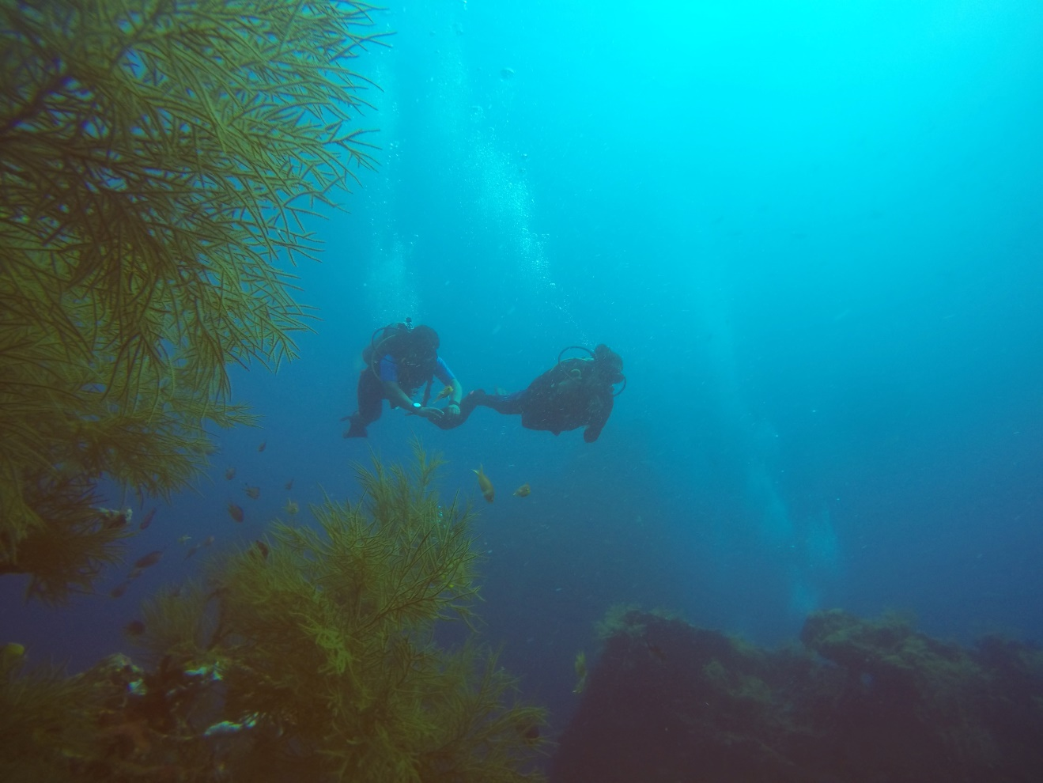

STA 06 (6 Nights/ 7 Days)
BREATHTAKING ANDAMAN (Port Blair 3N + Havelock 2N + Neil Island 1N)
Day 01: Arrival Port Blair + Half Day Local SS (Local Sightseeing point closed on Monday & on all Govt. holidays)
You arrive to Port Blair, our escorts in the airport pick receive you there and then after a short introduction will take you to your first booked hotel, after check-in and once you are done with you lunch & refreshment, we will take a tour to the historic cellular jail which will be followed by the light and sound show. (the history & migration to these archipelago revolves around this monumental architecture , once you finish taking the tour just after a gap of half an hour , you will witness the light & sound show , like any other light & sound it’s a narration of the story of the jail through light & sound ) day end here back to the hotel.
Day 02: Excursion North Bay (Coral Island), Ross Island & Back (Carry Changing Cloth, water & dry food)
(closed on Wednesday) After breakfast we will set out on a Sea Safari, we will reach the water sports complex from here we will take a luxury motor sail and explore the famous islands of North Bay coral island & the historic Ross Island, experience the fun of cruising and feel the joy of sailing through small big Island and discover the blue ocean and with the on board crew and activity experts who will there to assist you. Upon arrival back to the Port our escorts will arrange necessary transfers back to the respective hotel.
Day 03: Port Blair to Havelock Island
We start the day a bit early today as we need to embark for Havelock Island, the cruise depart at (6:45 am to 01:30 pm any time in between). So we have to report an hour early. Take a quick breakfast and head to Havelock Island the total journey time is around 1 and 1/2 hour by sea. Again once to reach in the island meet our escorts who will be standing outside the harbor restricted area with a name tag. Along with them proceed to your respective hotel and then plan you day, probably post lunch for Radhanagar beach. You can enjoy the beach as well as the sun set, which i guess is the best you can see.
(Boat transfers are subjected to change as per the availability of tickets and weather conditions).
Day 04: In Havelock Island
After Breakfast visit to Elephant Beach by Motor Boat for Mesmerizing View of Corals and Enjoy Snorkeling (Boat will be on sharing basis).Overnight stay at Resort in Havelock.
Day 05: Havelock Island to Neil Island
We will check-out the resort as per the schedule timing which is generally in the morning 0900 hours. And then proceed to board the cruise back to Neil Island. Once you arrive in Neil you will meet our escorts outside the exit area, check-in to hotel, finish lunch and then proceed to an excursion to Island visit all the beaches around the Island, night stay in Neil Island.
(While leaving from Port Blair to Havelock island probably you can leave your bigger luggage in port Blair, hotels in Port Blair provide clock room and take only two days cloths and necessary materials to Havelock island, by this way you can avoid the hassle of carrying it inside the harbor area, which is restricted place like the airport and do not have trolley facility)

Day 06: Neil Island to Port Blair (57 Kms)
After breakfast proceed to visit Sitapur Beach – One finest beach in this island , there after visit Lakhimpur beach , next to visit Beautiful Bharatpur beach – the ideal place for swimming , nature bridge. After visit drop at Jetty to catch the return boat for Port Blair , on Return to Port Blair back to your hotel evening free for own activity, Overnight stay at hotel.
Day 07: Departure from Port Blair
Morning free for packing & personal activities, on time 08:00am check out from the hotel & on time transfer to Airport. Tour Ends

TOUR COST PER PERSON IN RUPEES
COST PER PERSON ON CP | 02 PAX | 04 PAX | 06 PAX | EXTRA BED | CHILD WITHOUT BED
STANDARD | 25960 | 22770 | 21560 | 14520 | 12320
DELUXE | 29370 | 25960 | 24860 | 17380 | 13750
SUPERIOR | 38280 | 34760 | 33770 | 21120 | 16830
LUXURY | 43340 | 39930 | 38940 | 26840 | 20350
PREMIUM | 52690 | 49280 | 48290 | 33220 | 24640

MEAL SUPPLEMENT PER PERSON
MEAL SUPPLEMENT (NON COMMISSIONABLE) | PER MEAL PER PAX + 5% GST
STANDARD | 350 + 5% GST
DELUXE | 450 + 5% GST
SUPERIOR | 550 + 5% GST
LUXURY | 750 + 5% GST
PREMIUM | 850 + 5% GST

HOTELS USED IN THE PACKAGE
DESTINATION | STANDARD | DELUXE | SUPERIOR | LUXURY | PREMIUM
PORT BLAIR | HOTEL SHREESH / SIMILAR | J HOTEL / SIMILAR | TSG EMERALD VIEW / SIMILAR | PEERLESS RESORT / SIMILAR | SYMPHONY SAMUNDRA / SIMILAR
HAVELOCK | GOLD STAR BEACH RESORT / SIMILAR | ELDORADO BEACH RESORT / SIMILAR | TSG BLUE RESORT / SIMILAR | SYMPHONY PALMS RESORT / SIMILAR | SILVER SAND BEACH RESORT / SIMILAR
NEIL ISLAND | HOTEL SHREESH / SIMILAR | NEIL BANJARA / SIMILAR | TSG AURA RESORT / SIMILAR | PEARL PARK BEACH RESORT / SIMILAR | SUMMER SANDS BEACH RESORT / SIMILAR

VEHICLE USED IN THE PACKAGE
A/C Scorpio / Xylo (only 02 - 06 heads are allowed including child)

COST INCLUDES | COST EXCLUDES
- Accommodation in Twin Sharing in above mentioned hotels (base category rooms)  - Meals as mentioned above  - A/C car for all transfers and sightseeing (vehicle is not at disposal – only point to point)  - Entrance fee at Port Blair SS  - Boat Charge (Luxury Boat – Green Ocean or Makruzz – base category) for Havelock Island  - NAC Boat Tickets for Ross Island & North Bay Island  - Fiber Boat for Elephant island visit by Sharing | - Air Fare  - Personal Expenses  - Item that are not mentioned in the inclusions  - 5% Govt. service tax  - Guides & any Sports activities charges during sightseeing

STA 07 (7 Nights/ 8 Days)
UNFORGETABLE ANDAMAN (Port Blair 4N + Havelock 2N + Neil Island 1N)
Day 01: Arrival Port Blair + Half Day Local SS (Local Sightseeing point closed on Monday & on all Govt. holidays)
You arrive to Port Blair, our escorts in the airport pick receive you there and then after a short introduction will take you to your first booked hotel, after check-in and once you are done with you lunch & refreshment, we will take a tour to the historic cellular jail which will be followed by the light and sound show. (the history & migration to these archipelago revolves around this monumental architecture , once you finish taking the tour just after a gap of half an hour , you will witness the light & sound show , like any other light & sound it’s a narration of the story of the jail through light & sound ) day end here back to the hotel.
Day 02: Excursion North Bay (Coral Island), Ross Island & Back (Carry Changing Cloth, water & dry food)
(closed on Wednesday) After breakfast we will set out on a Sea Safari, we will reach the water sports complex from here we will take a luxury motor sail and explore the famous islands of North Bay coral island & the historic Ross Island, experience the fun of cruising and feel the joy of sailing through small big Island and discover the blue ocean and with the on board crew and activity experts who will there to assist you. Upon arrival back to the Port our escorts will arrange necessary transfers back to the respective hotel.
Day 03: Port Blair to Havelock Island
We start the day a bit early today as we need to embark for Havelock Island ,the cruise depart at (6:45 am to 01:30 pm any time in between). So we have to report an hour early . Take a quick breakfast and head to Havelock Island the total journey time is around 1 and 1/2 hour by sea. Again once to reach in the island meet our escorts who will be standing outside the harbor restricted area with a name tag. Along with them proceed to your respective hotel and then plan you day, probably post lunch for Radhanagar beach. You can enjoy the beach as well as the sun set, which i guess is the best you can see.
(Boat transfers are subjected to change as per the availability of tickets and weather conditions).
Day 04: In Havelock Island
After Breakfast visit to Elephant Beach by Motor Boat for Mesmerizing View of Corals and Enjoy Snorkeling (Boat will be on sharing basis). Overnight stay at Resort in Havelock.
Day 05: Havelock Island to Neil Island
We will check-out the resort as per the schedule timing which is generally in the morning 0900 hours. And then proceed to board the cruise back to Neil Island. Once you arrive in Neil you will meet our escorts outside the exit area, check-in to hotel, finish lunch and then proceed to an excursion to Island visit all the beaches around the Island, night stay in Neil Island.
(While leaving from Port Blair to Havelock island probably you can leave your bigger luggage in port Blair, hotels in Port Blair provide clock room and take only two days cloths and necessary materials to Havelock island, by this way you can avoid the hassle of carrying it inside the harbor area, which is restricted place like the airport and do not have trolley facility)

Day 06: Neil Island to Port Blair (57 Kms)
After breakfast proceed to visit Sitapur Beach – One finest beach in this island , there after visit Lakhimpur beach , next to visit Beautiful Bharatpur beach – the ideal place for swimming , nature bridge. After visit drop at Jetty to catch the return boat for Port Blair , on Return to port Blair back to your hotel evening free for own activity, Overnight stay at hotel.
Day 07: Port Blair Full Day Local SS (Local Sightseeing point closed on Monday & on all Govt. holidays)
After breakfast leisurely take a trip of Port Blair City Tour the tour includes visiting of Chatham Saw Mill - Asia`s oldest and largest, Anthropological Museum, Samudrika Museum – the naval marine museum and finally shop at govt. run emporium called Sagarika for handicrafts of these islands. Post Lunch visit the Corbin’s Cove Beach – 9 kms from Port Blair - a coconut palm fringed beach, ideal for swimming, sunbasking & bathing. Stay Overnight at respective Hotel / Resort at Port Blair.
Day 08: Departure from Port Blair
Morning free for packing & personal activities, on time 08:00am check out from the hotel & on time transfer to Airport. Tour Ends.

TOUR COST PER PERSON IN RUPEES
COST PER PERSON ON CP | 02 PAX | 04 PAX | 06 PAX | EXTRA BED | CHILD WITHOUT BED
STANDARD | 28930 | 25080 | 23760 | 15730 | 13200
DELUXE | 32780 | 28930 | 27720 | 19140 | 14850
SUPERIOR | 42460 | 38720 | 37400 | 23320 | 18260
LUXURY | 49060 | 45210 | 44000 | 30140 | 22550
PREMIUM | 59840 | 55990 | 54670 | 36740 | 26950

MEAL SUPPLEMENT PER PERSON
MEAL SUPPLEMENT (NON COMMISSIONABLE) | PER MEAL PER PAX + 5% GST
STANDARD | 350 + 5% GST
DELUXE | 450 + 5% GST
SUPERIOR | 550 + 5% GST
LUXURY | 750 + 5% GST
PREMIUM | 850 + 5% GST

HOTELS USED IN THE PACKAGE
DESTINATION | STANDARD | DELUXE | SUPERIOR | LUXURY | PREMIUM
PORT BLAIR | HOTEL SHREESH / SIMILAR | J HOTEL / SIMILAR | TSG EMERALD VIEW / SIMILAR | PEERLESS RESORT / SIMILAR | SYMPHONY SAMUNDRA / SIMILAR
HAVELOCK | GOLD STAR BEACH RESORT / SIMILAR | ELDORADO BEACH RESORT / SIMILAR | TSG BLUE RESORT / SIMILAR | SYMPHONY PALMS RESORT / SIMILAR | SILVER SAND BEACH RESORT / SIMILAR
NEIL ISLAND | HOTEL SHREESH / SIMILAR | NEIL BANJARA / SIMILAR | TSG AURA RESORT / SIMILAR | PEARL PARK BEACH RESORT / SIMILAR | SUMMER SANDS BEACH RESORT / SIMILAR

VEHICLE USED IN THE PACKAGE
A/C Scorpio / Xylo (only 02 - 06 heads are allowed including child)
COST INCLUDES | COST EXCLUDES
- Accommodation in Twin Sharing in above mentioned hotels (base category rooms)  - Meals as mentioned above  - A/C car for all transfers and sightseeing (vehicle is not at disposal – only point to point)  - Entrance fee at Port Blair SS  - Boat Charge (Luxury Boat – Green Ocean or Makruzz – base category) for Havelock Island  - NAC Boat Tickets for Ross Island & North Bay Island  - Fiber Boat for Elephant island visit by Sharing | - Air Fare  - Personal Expenses  - Item that are not mentioned in the inclusions  - 5% Govt. service tax  - Guides & any Sports activities charges during sightseeing

TERMS & CONDITIONS
- Every tourist should send a Xerox copy of their voter’s identity card or passport and three passport size photographs at least ten days before the tour starts. Tourists should carry their id cards at all times during the tour.
- Booking to be confirmed before 15 days with payment.
- Cancellation charge of 50% if cancelled before 7 days, 75% if cancelled before 3 days and 100% if cancelled on the date of commencement of tour.
- Company does not have any liability if the tour is cancelled or itinerary changed during the tour due to any unpredictable event.
- Company does not cover insurance in case of any accidents or loss of belongings, etc.
- GST Extra.

VALIDITY: 01ST APRIL 2024 TO 15TH JULY 2024
Please note that these packages are offered at net rates and are non-commissionable.
We believe that these packages will provide exceptional value to your clients and help you expand your offerings. We look forward to a successful partnership with you and your agency. Should you have any questions or require further information, please do not hesitate to contact us.
Thank you for considering Shah Tours as your preferred travel partner.
Warm regards,
Ajay Shah / Abhay Shah
B - 56, Satellite Township,, Dabgram, Siliguri - 734015
Mobile: 99320 31500 / 94341 31500 / After Office: Call On: 9800060007
E-mail: shahtours2001@yahoo.com, shahtours2001@gmail.com , Web: www.shahtour.com
WE SPECIALIZE IN DARJEELING & SIKKIM, NORTH EAST, ANDAMANS, BHUTAN & NEPAL

