BHUTAN PACKAGE

Bhutan Package No: 01
04 Nights / 05 Days Package
Thimphu 02 Nights / Paro 02 Nights

Day 01 :Phuncholing to Thimphu
Meet and greet on arrival at Phuntsholing complete the immigration formalities and transfer to Thimphu (7,710 ft.) the capital city of Bhutan. On arrival check in at the hotel. Overnight stay at Thimphu.

Day 02 :Thimphu Local Sight Seen
After breakfast, day is dedicated to sightseeing of Thimphu.You will see the following tourist sites in Thimphu include:-
Kuenselphodrang , National Memorial Chorten, Folk Heritage Museum, Typical Bhutanese lunch at the Folk Heritage Restaurant would be a great experience, Sangaygang view point, Takin Reserve Centre, Changangkha Monastery, Tashichho Dzong (Fortress of the Glorious Religion) , Overnight Stay at Thimphu hotel.

Day 03 :- Transfer to Paro from Thimphu
After breakfast, Next you will be enjoying a drive from Thimphu to Paro. Paro is located at a distance of 65 kms from Thimphu.After breakfast, drive to Paro. On the way to Paro, visit the Tamchog Lhakhang.Other tourist attractions that you will be covering include:- Tamchog lhakhang , Rinpung Dzong , Ta Dzong, Evening free , Overnight Stay at Paro hotel.

Day 04 :- Paro Local Sight Seen
After breakfast go for full day sight seen of Paro. You will see the following tourist sites in Paro include:-
View of Taktshang Monastery, Nya-mey Zam, Dungtse Lhankhang, Kila Gompa, Druk Choeding. In Evening, Stroll Through the Market of Paro & overnight Stay in Paro.
OR
After early morning breakfast, you will be starting a Excursion tour to Taktshang Monastery.Taksand Palphug Monastery also known as Tiger's Nest is an amazing Buddhist monastery, temple and sacred site is located in the upper Paro town. Built in 1692, Padmasambhava is believed to have meditated at this site for 3 years. Guru Padmasambhava is known to be the founder of Buddhist religion in Bhutan. He is immensely respected and has a huge number of sacred followers in Bhutan. In Evening, Stroll Through the Market of Paro & overnight Stay in Paro.

Day 05 :- Paro to Phuncholing Drop
After breakfast check out from hotel and drop transfer to Phuncholing , for your onwards journey.

Package Cost ( Per Person )
PARTICULARS | PER HEAD RATE
GROUP SIZE : FOR 2 PAX | 29,600.00
GROUP SIZE : FOR 4 PAX | 24,700.00
GROUP SIZE : FOR 6 PAX | 21,500.00
GROUP SIZE : FOR 8 PAX | 20,300.00
GROUP SIZE : FOR 10 PAX | 20,400.00
GROUP SIZE : FOR 12 PAX | 19,500.00
GROUP SIZE : FOR 14 PAX | 18,900.00

Hotel Use In Package --- 3 Star Properties.
DESTINATION | NO OF NIGHTS | HOTEL NAME | TYPE | MEALS
THIMPHU | 2N | HOTEL MIGMAR / SIMILAR | STD | CPAI ( Breakfast Only )
PARO | 2N | NAMSEY CHOLING RESORT/SIMILAR | STD | CPAI ( Breakfast Only )

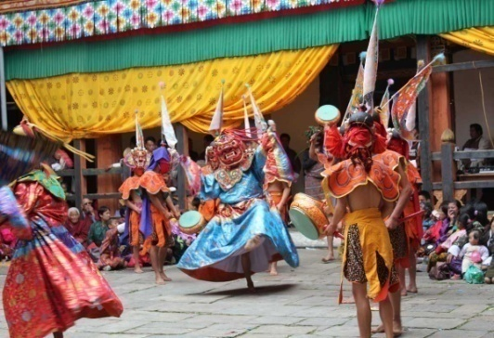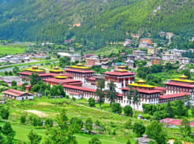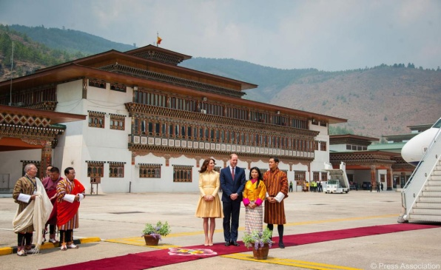

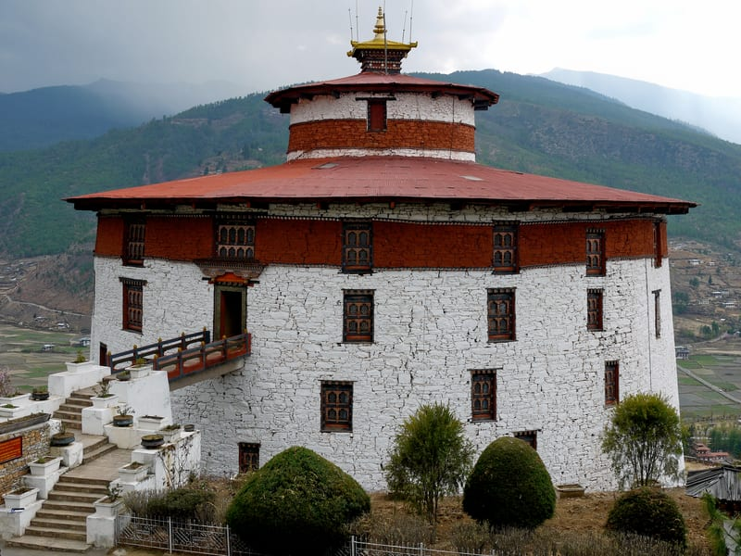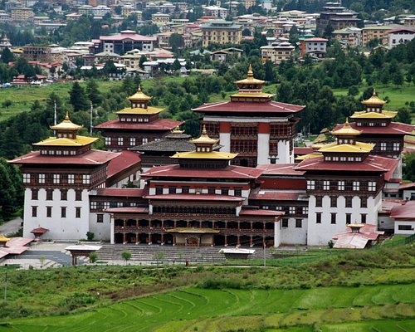

Bhutan Package No: 02
05 Nights / 06 Days Package
Thimphu 02 Nights / Punakha 01 Night / Paro 02 Nights

Day 01 : Phuncholing to Thimphu ,
Meet and greet on arrival at Phuntsholing complete the immigration formalities and transfer to Thimphu (7,710 ft.) the capital city of Bhutan. On arrival check in at the hotel. Overnight stay at Thimphu.

Day 02 :Thimphu Local Sight Seen
After breakfast, day is dedicated to sightseeing of Thimphu.You will see the following tourist sites in Thimphu include
,Kuenselphodrang, National Memorial Chorten, Folk Heritage Museum,Typical Bhutanese lunch at the Folk Heritage Restaurant would be a great experience. Sangaygang view point ,Takin Reserve Centre , Changangkha Monastery, Tashichho Dzong (Fortress of the Glorious Religion) Dinner and Overnight Stay at Thimphu hotel.

Day 03 :- Thimphu to Punakhka
After breakfast, you will be taken on a three hour road trip from Thimphu to Punakha / Wangdue Phodrang, which is located across the famous Dochu La Pass. During the road trip, you will pass through the Dochula, where you will spot mani wall, chorten, prayer flags, and others. This is the country’s highest road. You can even spot the peaks of surrounding mountains, if the sky is clear. Top peaks to spot during your drive are Masagang, Tsendagang, Terigang, Kangphugang, Table Mountain, and others. This includes the Gangkhar Puensum peak, which is the highest in Bhutan.On Arrival Check Into the Hotel. Post Lunch You will see the following tourist sites in Punakha /Wangdue include:- Punakha Dzong , Chimi Lhakhang, Punakha Suspension Bridge, Punakha Village, Jigme Dorji National Park Back to hotel. Overnight Stay in Punakha / Wangdue.

Day 04 :- Punakha / Wangdue to Paro
After breakfast, you will leave Punakha/Wangdue and drive to Paro via Dochu La Pass, covering Paro Chuu river valley and Wang Chhu river valley. On the way, you will be visiting Simtokha Dzong, an old fortress which is now a school for Dzongkha language. Once you reach Paro, you will be checked into a hotel. Later, you will be taken on a sightseeing tour covering important destinations of Paro:- Ta Dzong, Rinpung Dzong, Tamchog lhakhang Back to hotel. Overnight Stay in Paro.

Day 05 :- Paro Local Sight Seen
After early morning breakfast, you will be starting a Excursion tour to Taktshang Monastery.Taksand Palphug Monastery also known as Tiger's Nest is an amazing Buddhist monastery, temple and sacred site is located in the upper Paro town. Built in 1692, Padmasambhava is believed to have meditated at this site for 3 years. Guru Padmasambhava is known to be the founder of Buddhist religion in Bhutan. He is immensely respected and has a huge number of sacred followers in Bhutan. Dinner and Overnight at the Paro hotel.

Day 06 :- Paro to Hasimara Railway Station Drop
After breakfast check out from hotel and drop transfer to Hasimara Railway Station, for your onwards jpurney.

Package Cost ( Per Person )

PARTICULARS | PER HEAD RATE | TOTAL AMOUNT
GROUP SIZE : FOR 2 PAX | 35,400.00 | 70,800.00
GROUP SIZE : FOR 4 PAX | 29,500.00 | 1,18,000.00
GROUP SIZE : FOR 6 PAX | 25,800.00 | 1,54,800.00
GROUP SIZE : FOR 8 PAX | 24,300.00 | 1,94,400.00
GROUP SIZE : FOR 10 PAX | 24,400.00 | 2,44,000.00
GROUP SIZE : FOR 12 PAX | 23,300.00 | 2,79,600.00
GROUP SIZE : FOR 14 PAX | 22,600.00 | 3,16,400.00

Hotel Use In Package --- 3 Star Properties.

DESTINATION | NO OF NIGHTS | HOTEL NAME | TYPE | MEALS
THIMPHU | 2N | HOTEL MIGMAR / SIMILAR | STD | CPAI ( Break Fast Only )
PUNAKHA | 1N | HOTEL KINGALING / SIMILAR | STD | CPAI ( Break Fast Only )
PARO | 2N | NAMSEY CHOLING RESORT/SIMILAR | STD | CPAI ( Break Fast Only )

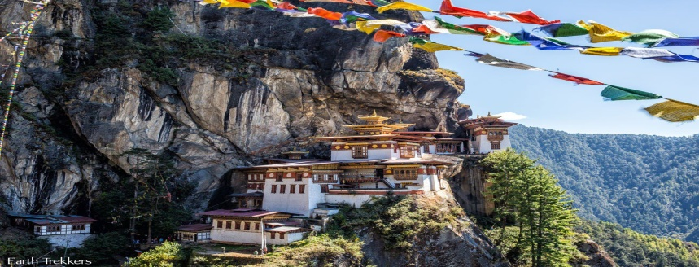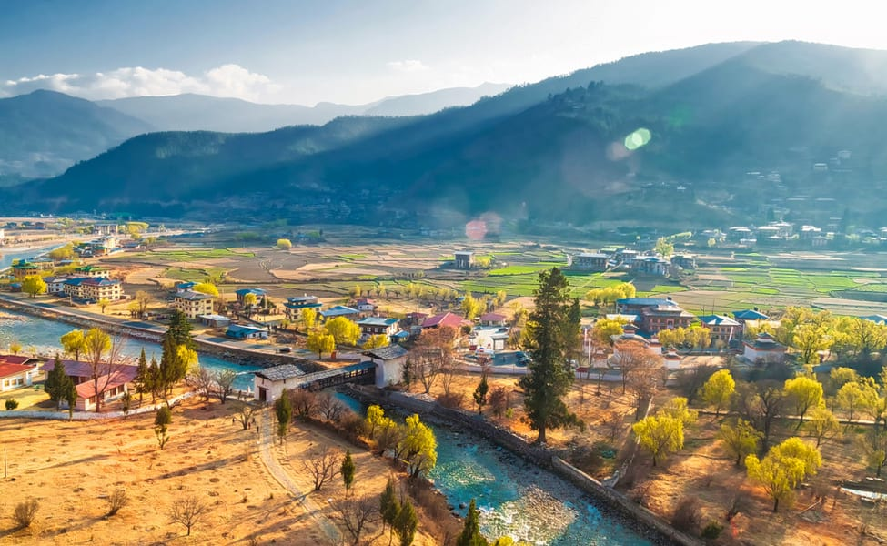

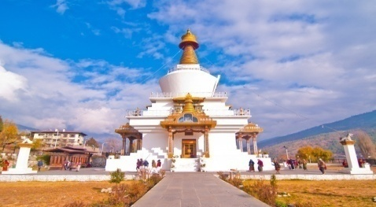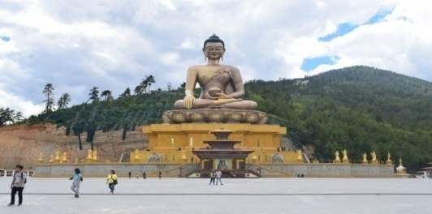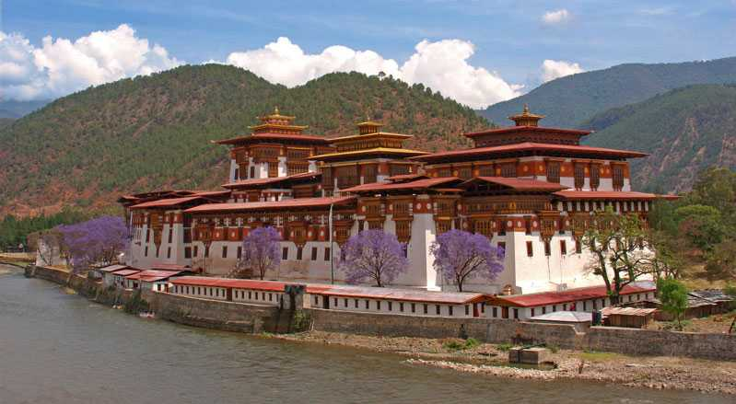

Bhutan Package No: 03
06 Nights / 07 Days Package
Phuencholing 02 Nights / Thimphu 02 Nights / Paro 02 Nights

Day 01 : NJP Rly Station / IXB Airport – Phuentsholing(Distance: 170 kms. / Driving Time: 5 hrs. / Altitude of Phuentsholing: 293 mts.)
Meet & Greet on arrival at NJP Railway Station / IXB Airport and transfer to Phuentsholing - The Gateway of Bhutan by Road from India. It is a thriving commercial center on the northern edge of the Indian Plains. On arrival check in at the hotel. Overnight stay at Phuentsholing.

Day 02 :Phuentsholing to Thimphu (Distance: 176 kms. / Driving Time: 6 hrs. / Altitude of Thimphu: 2350 mts.)
After breakfast , proceed towards Thimpu via the wonderful mystic town Gedu, which is about 9000 ft above the sea and Chukha Dam. On the way, halt at Chojum to take photographs of confluence of two rivers of Bhutan, Thumpu Chu and Paro Chu. Reach Thimpu in the evening. On arrival check in at the hotel. In the evening, visit theTashichho Dzong (Fortress of the Glorious Religion). Overnight stay at Thimphu.

Day 03 :Thimphu Local Sight Seen
After breakfast, day is dedicated to sightseeing of Thimphu.You will see the following tourist sites in Thimphu include:-
Kuenselphodrang, National Memorial Chorten, Folk Heritage Museum, Typical Bhutanese lunch at the Folk Heritage Restaurant would be a great experience., Sangaygang view point, Takin Reserve Centre, Changangkha Monastery, Tashichho Dzong (Fortress of the Glorious Religion), Dinner and Overnight Stay at Thimphu hotel.

Day 04 :- Transfer to Paro from Thimphu
Next you will be enjoying a drive from Thimphu to Paro. Paro is located at a distance of 65 kms from Thimphu.After breakfast, drive to Paro. On the way to Paro, visit the Tamchog Lhakhang.Other tourist attractions that you will be covering include:- Tamchog lhakhang, Rinpung Dzong, Ta Dzong Dinner and Overnight Stay at Paro hotel.

Day 05 :- Paro Local Sight Seen

After breakfast go for full day sight seen of Paro. You will see the following tourist sites in Paro include:-View of Taktshang Monastery, Nya-mey Zam,Dungtse Lhankhang, Kila Gompa, Druk Choeding.
OR
After early morning breakfast, you will be starting a Excursion tour to Taktshang Monastery.Taksand Palphug Monastery also known as Tiger's Nest is an amazing Buddhist monastery, temple and sacred site is located in the upper Paro town. Built in 1692, Padmasambhava is believed to have meditated at this site for 3 years. Guru Padmasambhava is known to be the founder of Buddhist religion in Bhutan. He is immensely respected and has a huge number of sacred followers in Bhutan. In Evening, Stroll Through the Market of Paro & overnight Stay in Paro.

Day 06 :- Paro to Phuentsholing
After breakfast check out from hotel and transfer to Phuentsholing. On arrival check in at the hotel. Overnight stay at Phuentsholing.

Day 07 :- Phuentsholing to Bagdogra Airport / NJP Railway Station Drop
After breakfast check out from the hotel and take the departure transfer to NJP Railway Station / IXB Airport for your onward journey.

Package Cost ( Per Person )

PARTICULARS | PER HEAD RATE | TOTAL AMOUNT
GROUP SIZE : FOR 2 PAX | 35,600.00 | 71,200.00
GROUP SIZE : FOR 4 PAX | 29,500.00 | 1,18,000.00
GROUP SIZE : FOR 6 PAX | 25,900.00 | 1,55,400.00
GROUP SIZE : FOR 8 PAX | 25,200.00 | 2,01,600.00
GROUP SIZE : FOR 10 PAX | 24,900.00 | 2,49,000.00
GROUP SIZE : FOR 12 PAX | 23,900.00 | 2,86,800.00
GROUP SIZE : FOR 14 PAX | 23,800.00 | 3,33,200.00

Hotel Use In Package --- 3 Star Properties.
DESTINATION | NO OF NIGHTS | HOTEL NAME | TYPE | MEALS
PHUENTSHOLING | 2N | HOTEL PARK / SIMILAR | STD | CPAI
THIMPHU | 2N | HOTEL MIGMAR / SIMILAR | STD | CPAI
PARO | 2N | NAMSEY CHOLING RESORT/SIMILAR | STD | CPAI

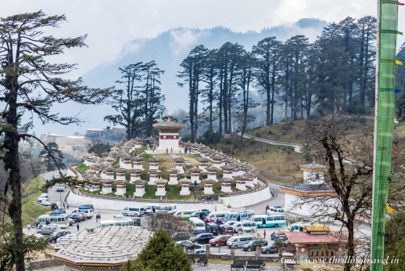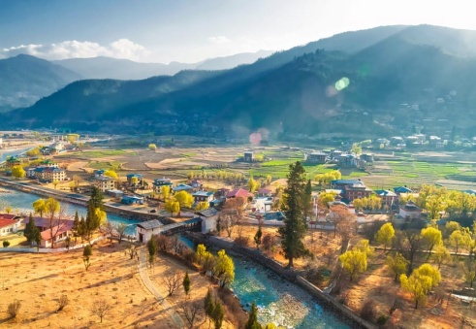

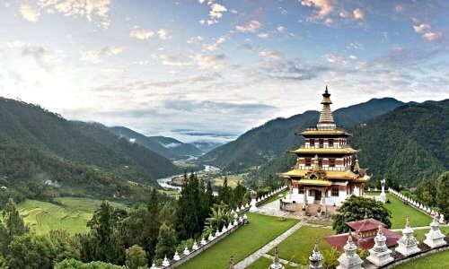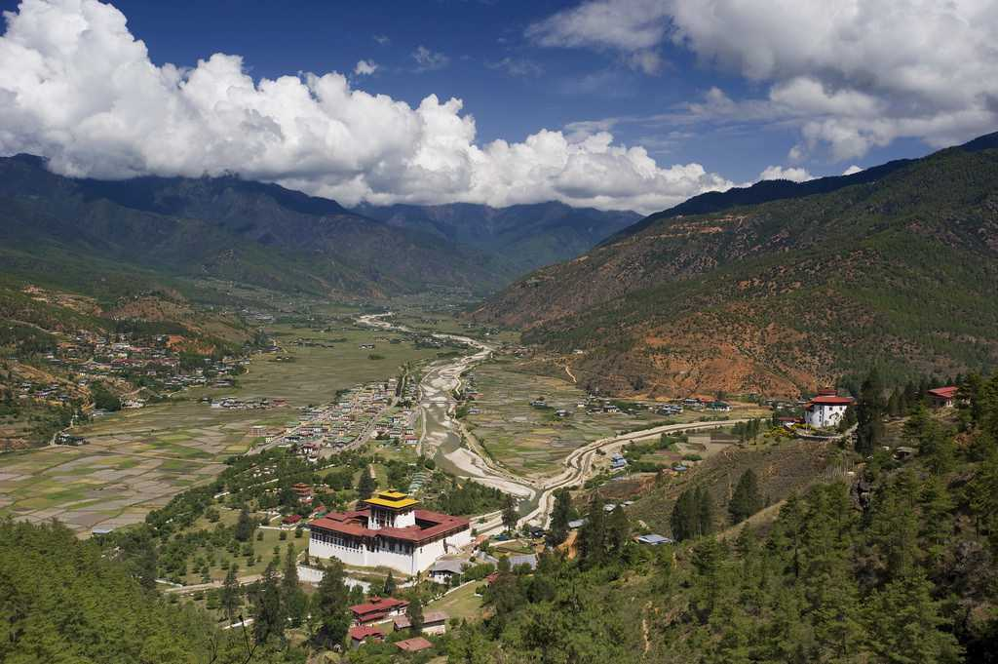

Bhutan Package No: 04
07 Nights / 08 Days Package
Phuencholing 02 Nights / Thimphu 02 Nights / Punakha 01 Night / Paro 02 Nights

Day 01 : NJP Rly Station / IXB Airport – Phuentsholing(Distance: 170 kms. / Driving Time: 5 hrs. / Altitude of Phuentsholing: 293 mts.)
Meet & Greet on arrival at NJP Railway Station / IXB Airport and transfer to Phuentsholing - The Gateway of Bhutan by Road from India. It is a thriving commercial center on the northern edge of the Indian Plains. On arrival check in at the hotel. Overnight stay at Phuentsholing.

Day 02 :Phuentsholing to Thimphu (Distance: 176 kms. / Driving Time: 6 hrs. / Altitude of Thimphu: 2350 mts.)
After breakfast , proceed towards Thimpu via the wonderful mystic town Gedu, which is about 9000 ft above the sea and Chukha Dam. On the way, halt at Chojum to take photographs of confluence of two rivers of Bhutan, Thumpu Chu and Paro Chu. Reach Thimpu in the evening. On arrival check in at the hotel. In the evening, visit theTashichho Dzong (Fortress of the Glorious Religion). Overnight stay at Thimphu.

Day 03 :Thimphu Local Sight Seen
After breakfast, day is dedicated to sightseeing of Thimphu.You will see the following tourist sites in Thimphu include:-
Kuenselphodrang, National Memorial Chorten, Folk Heritage Museum, Typical Bhutanese lunch at the Folk Heritage Restaurant would be a great experience., Sangaygang view point, Takin Reserve Centre, Changangkha Monastery, Tashichho Dzong (Fortress of the Glorious Religion), Dinner and Overnight Stay at Thimphu hotel.

Day 04 :- Thimphu to Punakhka
After breakfast, you will be taken on a three hour road trip from Thimphu to Punakha / Wangdue Phodrang, which is located across the famous Dochu La Pass. During the road trip, you will pass through the Dochula, where you will spot mani wall, chorten, prayer flags, and others. This is the country’s highest road. You can even spot the peaks of surrounding mountains, if the sky is clear. Top peaks to spot during your drive are Masagang, Tsendagang, Terigang, Kangphugang, Table Mountain, and others. This includes the Gangkhar Puensum peak, which is the highest in Bhutan.On Arrival Check Into the Hotel. Post Lunch You will see the following tourist sites in Punakha /Wangdue include:- Punakha Dzong , Chimi Lhakhang, Punakha Suspension Bridge, Punakha Village, Jigme Dorji National Park Back to hotel. Overnight Stay in Punakha / Wangdue.

Day 05 :- Punakha / Wangdue to Paro
After breakfast, you will leave Punakha/Wangdue and drive to Paro via Dochu La Pass, covering Paro Chuu river valley and Wang Chhu river valley. On the way, you will be visiting Simtokha Dzong, an old fortress which is now a school for Dzongkha language. Once you reach Paro, you will be checked into a hotel. Later, you will be taken on a sightseeing tour covering important destinations of Paro:- Ta Dzong, Rinpung Dzong, Tamchog lhakhang Back to hotel. Overnight Stay in Paro.

Day 06 :- Paro Local Sight Seen
After early morning breakfast, you will be starting a Excursion tour to Taktshang Monastery.Taksand Palphug Monastery also known as Tiger's Nest is an amazing Buddhist monastery, temple and sacred site is located in the upper Paro town. Built in 1692, Padmasambhava is believed to have meditated at this site for 3 years. Guru Padmasambhava is known to be the founder of Buddhist religion in Bhutan. He is immensely respected and has a huge number of sacred followers in Bhutan. Dinner and Overnight at the Paro hotel.

Day 07 :- Paro to Phuentsholing
After breakfast check out from hotel and transfer to Phuentsholing. On arrival check in at the hotel. Overnight stay at Phuentsholing.

Day 08 :- Phuentsholing to Bagdogra Airport / NJP Railway Station Drop
After breakfast check out from the hotel and take the departure transfer to NJP Railway Station / IXB Airport for your onward journey.

Package Cost ( Per Person )

PARTICULARS | PER HEAD RATE | TOTAL AMOUNT
GROUP SIZE : FOR 2 PAX | 41,300.00 | 82,600.00
GROUP SIZE : FOR 4 PAX | 34,400.00 | 1,37,600.00
GROUP SIZE : FOR 6 PAX | 30,200.00 | 1,81,200.00
GROUP SIZE : FOR 8 PAX | 29,200.00 | 2,33,600.00
GROUP SIZE : FOR 10 PAX | 28,900.00 | 2,89,000.00
GROUP SIZE : FOR 12 PAX | 27,700.00 | 3,32,400.00
GROUP SIZE : FOR 14 PAX | 27,500.00 | 3,85,000.00

Hotel Use In Package --- 3 Star Properties.
DESTINATION | NO OF NIGHTS | HOTEL NAME | TYPE | MEALS
PHUENTSHOLING | 2N | HOTEL PARK / SIMILAR | STD | CPAI
THIMPHU | 2N | HOTEL MIGMAR / SIMILAR | STD | CPAI
PUNAKHA | 1N | HOTEL KINGALING / SIMILAR | STD | CPAI
PARO | 2N | NAMSEY CHOLING RESORT / SIMILAR | STD | CPAI

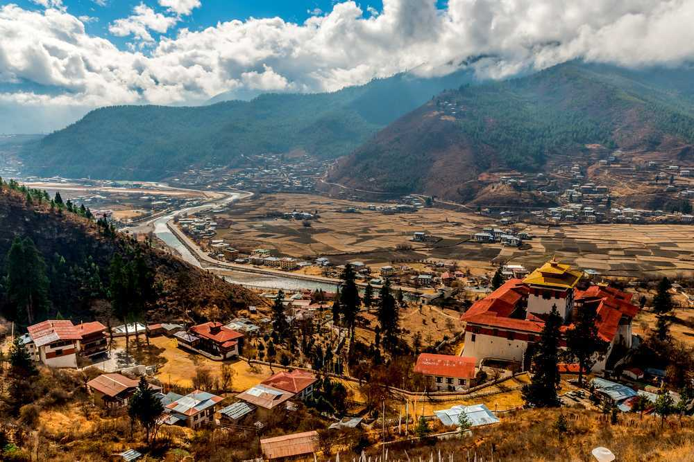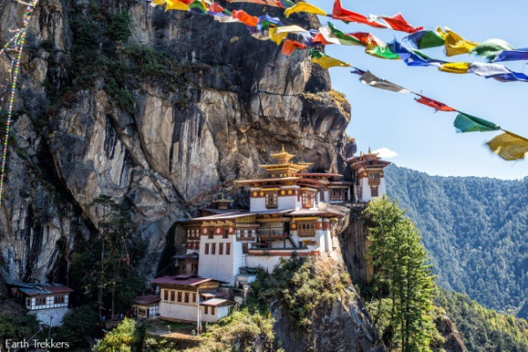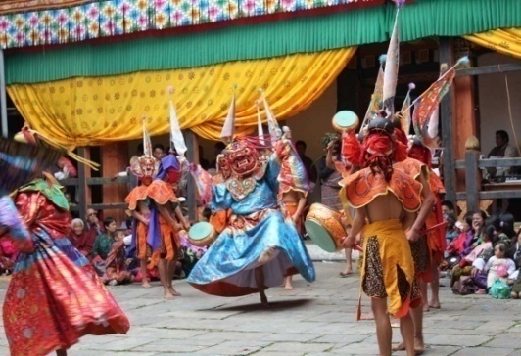

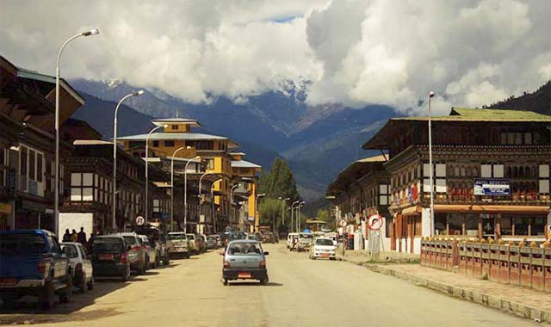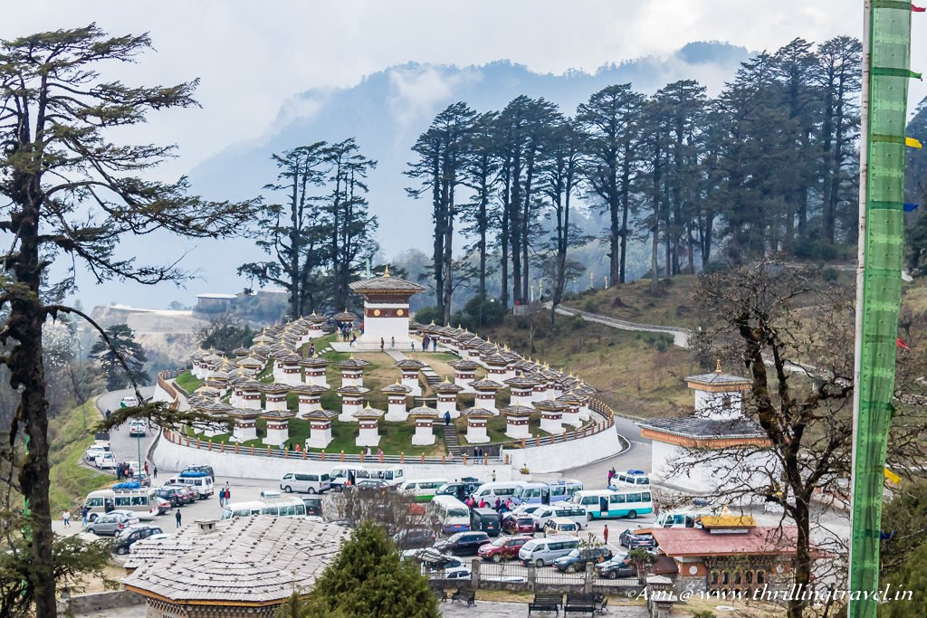

BHUTAN PACKAGE RATE ARE NET & NON COMMISSIONABLE
Note :-
- Above quote is valid if all the pax is travelling together - In case of any changes in number of pax, rate /Dot will attract the re quote.
- The above mentioned hotels & rooms are subject to availability.
- If the above mentioned hotels are not available then the similar category hotels will be provided.
- HOTEL CHECK IN TIME 1200 NOON & CHECK OUT TIME 1100 HRS.
- Request for early check in may be considered depending on room availability.
- Request for late checkout may be considered depending on room availability and chargeable on request.
Package Inclusion :-
- Transfer all in private basis in Non Ac exclusive Santaffee/Tucsan/Creta / Hice Bus/Coaster Bus
- Sight Seen as per the itinerary point to point basis.
- Pick up from Hasimara Railway Station and drop Hasimara Railway Station
- India part by WagonR/Innova/Xylo / Crysta / Similar
- 3 Star Accommodation in all places
- Accommodation on double sharing basis
- Meal plan : Breakfast
- One bottle Mineral Water per head per day
- Sustainable Development Fees (SDF) Rs.1,200/- Per head / Per Night
- Professional English Speaking Guide
- One tourist Sim Card on Arrival
- 5 % GST.
- All Govts. Taxes
Package Exclusion
- Extras of personal nature such as personal tips, laundry charges,additional tour charges.
- Driver tips
- Does not include any Lunch & Evening Tea/snacks
- Insurance, Medical & Emergency rescue costs
- Does not include Hard drinks or liquor or soft drinks/juices.
- Does not include Entrance Fees at Monasteries / Monuments /Museums etc.
- Air Fare / Train Tickets
- Additional sightseeing or extra usage of vehicle, other than mentioned in the itinerary.
- Mini bar
- Any cost arising due to natural calamities like, landslides, road blockage, political disturbances (strikes), etc (to be borne by the client, which is directly payable on the spot).
- Any increase in taxes or fuel price, leading to increase in cost on surface transportation & land arrangements, which may come into effect prior to departure.

Child Policy
- Child Below 5 years will be complimentary.
- Child 5 -12 years without extra bed as mention in cost column CNB (Child no Bed)
- Child 5 -12 yrs with extra bed as mention in cost column CWB (Child with Bed)
- Above 12 years / Extra adult with an extra bed sharing room are same & charged as per.
Document Require
- Original Valid Passport (Minimum 6 Months Validity )
- 2 copies Pass Port size color Photographs
- Double Dose vaccination certificate
About Vehicle:
- We provide exclusive vehicles in our packages.
- Non A/c Santaffee / Tucsan/ Creta / Prado (4 Seater ) for 1-3 Pax .
- Non A/c Luxury Hice Bus ( 10 Seater ) for 4-9 pax .
- Non A/c Luxury Coaster Bus( 19 Seater) for 8-18 pax .

Payment Policy

- Any confirmation is subject to an advance deposit of 50 % of the package cost and has to be paid immediately upon the confirmation.
- Balance Payment has to be made in advance before 15 days of arrival.
- Please send your billing instruction
i) Billing Name
ii) Billing Address with pin code
iii) Buyer GSTIN

- Tax Invoice will be given after completion of services. In case perform invoice is required to release the payment please advise us.
- We do not accept Cash Receipts or Cash Payments in Account. If any cash is deposited in our Bank Account it will be considered as 100% penalty & no service will be rendered.
- Please make Payments by Cheque / Bank Transfer / RTGS / NEFT / IMPS Only.
- No booking are guaranteed without advance payment and rates are subject to availability.

BANK | Yes Bank
ACCOUNT NAME | Shah Tours & Travels
ACCOUNT NO. | 055263400002230
BRANCH | Sevok Road , Siliguri
IFSC | YESB0000552

After depositing the payment, please mail us at shahtours2001@yahoo.com

Refund Rules:-
- Refund will be paid to the source through which the guest has booked. Any refund will take at least 20 days to process & will be sent to you by a/c payee cheque only.
- NO REFUND WILL BE MADE AGAINST ANY UN UTILIZED SERVICES AFTER COMMENCEMENT OF TOUR, WHAT SO EVER MAY BE THE REASON.
Cancellation Policy:-

- Cancellation has to be sent to us by Email.
- From Date of booking – 35 days and above only communication charges of Rs. 2000.00 per person or 10% of total amount + 18% GST whichever is lower.
- Within 30 days of the date of arrival - 50 % (Per cent)
- Within 15 days of the date of arrival – 100 % (Per cent )
- Cancellation received less than 15 days “Regular Season” & less than 25 days “High Season”prior to check in will incur 100 % cancellation fee.
- No refund / No postponement if the cancellation is affected 15 days prior to the check in date.
- In case of Natural Calamity / Strike / Political Disturbances, if Roads remain open – the above Cancellation Policy will be applicable.

We do hope that you find all in order, thanking you & us assuring our best services at all time.
For any further clarification, please feel free to contact us any time.
Thanks & Regards
Ajay Shah / Abhay Shah
Shah Tour and Travels
B - 56, Satellite Township, ,Dabgram, Siliguri. 734015,
Phone: 0353 – 2541500 / 2542500
Mobile : 99320 31500 / 94341 31500
E-mail : shahtours2001@yahoo.com, shahtours2001@gmail.com Web: www.shahtour.com
After Office : Call On: 9800060007
Contact us for : Hotel Reservation / Car & Coach Rental / Package Tour of Darjeeling – Sikkim, Nepal – Bhutan Packages , Andaman Package
Domestic and International / Packages / LTC Packages.
21 YEARS OF EXCELLENCE IN ALL TRAVEL RELATED SERVICES.
Our Motto is to develop, maintain trust & achieve sustainable development.......

We are specialize in:
Sikkim - Darjeeling , Dooars, North East India, Andaman, Himachal ,Bhutan , Nepal

