Dear Travel Partners,
Greetings from SHAH TOUR, Darjeeling!
Are you planning to spend your vacations in the cool and mountainous NEPAL? Or do you want to savor the beauty of Chitwan or explore the mystic land of Pokhra? Do you want to make the experience of travelling in hills not just memorable but secure and comfortable for your family and friends? Then you are in the right place. Shah Tour has been serving its customers for nearly two decades with incessant dedication. We understand the needs of our customers and the value of their hard earned money. Therefore, we never tend to compromise the services provided to our customers. Our trained, experienced and hospitable staff will make sure that your experience of vacation is comfortable, secure and memorable. Shah Tour specializes in customized and fixed departure holiday options for Nepal, Bhutan , Sikkim, Darjeeling, Dooars and Andamans & Nicobar. We provide car rental services, air, bookings, hotel bookings and other travel-related services at a reasonable price. Our excellent contacts with all major hotels and airlines make it easier for us to provide desired services. Our holiday packages are designed keeping in mind the general requirements of our customers. However, we also have a plan of flexible and personalized packages for them. You tell us the destination and we will make a personalized package for you. All this in an affordable price. We have managed not only to serve but excellently serve our customers.
Find package for Nepal (given below) valid from 01st Oct 2022 to 31st March 2023
Note: This rate are Not Valid from: 20.12.22 to 10.01.223
RATES ARE NET AND NON COMMISSIONABLE
YOUR VALUABLE SUGGESTION /FEED BACKS ARE ALWAYS WELCOME
OFFICES AT: DARJEELING, SILIGURI, & GANGTOK
Thanks & Regards
Ajay Shah / Abhay Shah

Shah Tour and Travels
Contact us for : Domestic & International Air Tickets / Hotel Reservation / Car Rental .
Domestic and International / Packages / LTC Packages.
21 YEARS OF EXCELLENCE IN ALL TRAVEL RELATED SERVICES.
NEPAL TOUR PACKAGE - 2022 / 23
CURATED BY SHAH TOURS
PACKAGE NUMBER | CITIES TO BE VISITED | TOTAL NIGHTS
STTN 01 | 03 KATHMANDU | 03
STTN 02 | 02 KATHMANDU & 02 POKHARA | 04
STTN 03 | 02 KATHMANDU / 02 POKHARA & 01 JOMSOM | 05
STTN 04 | 03 KATHMANDU & 02 POKHARA | 05
STTN 05 | 03 KATHAMNDU / 02 POKHRA & 01 JOMSOM | 06
STTN 06 | 02 KATHMANDU / 02 POKHARA & 0 2 CHITWAN | 06
STTN 07 | 03 KATHMANDU / 02 POKHARA & 02 CHITWAN | 07
STTN 08 | 03 KATHMANDU / 02 POKHARA / 01 LUMBINI & 02 CHITWAN | 08
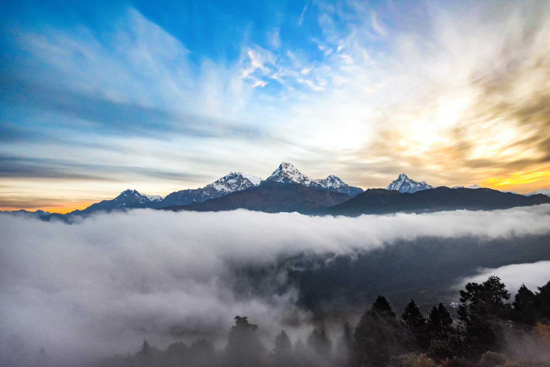
STTN 01: KATHMANDU
KATHMANDU 03 NIGHTS

Day 01 : Arrive in Kathmandu Upon arrival in Kathmandu Airport, you will be greeted and assisted by our Representative. After completing your custom formalities, transfer to Hotel for check-in. Afternoon, visit Boudhanath Stupa. Evening, attend aarati at Pashupatinath Temple. Drive back to Hotel. Overnight at Kathmandu Hotel .
Day 02 : Kathmandu Sightseeing Breakfast is at Hotel. After breakfast, visit Swoyambhunath Stupa, Jala Narayan Temple (Sleeping Vishnu). Next, visit Kathmandu Durbar Square. Drive back to Hotel. Overnight is at Hotel in Kathmandu.
Day 03 : Kathmandu - Chandragiri Hill by Cable Car After breakfast drive to Chandragiri hill then continue take Cable car ride (3 Hours) darshan back to Kathmandu later visit Patan Darbur Squire (Krishna Mandir). Overnight is at Hotel in Kathmandu.
Day 04: Kathmandu – Departure transfer After breakfast ,the morning will be comparatively free and closer to the time of your flight ,you will be transferred to the airport to board your flight for onward journey.

COST PER PERSON IN INR: (CP/BB – With B/ Breakfast Plan)
CATEGORY | 2-3 | 4-6 | 7-9 | 10-13 | 14-17 | 18-25 | 26-30 | 31-35
3 Star | 12,500 | 10,900 | 10,500 | 9,800 | 9,600 | 9,400 | 9,300 | 9,200
4 Star | 14,500 | 12,900 | 12,500 | 11,800 | 11,600 | 11,400 | 11,300 | 11,200
5 Star | 18,900 | 17,500 | 16,800 | 16,500 | 16,200 | 15,900 | 15,600 | 15,100

COST PER PERSON IN INR: (MAPAI – With B/ Breakfast & Dinner Plan)
CATEGORY | 2-3 | 4-6 | 7-9 | 10-13 | 14-17 | 18-25 | 26-30 | 31-35
3 Star | 13,400 | 11,800 | 11,400 | 10,700 | 10,500 | 10,300 | 10,200 | 10,100
4 Star | 16,300 | 14,700 | 14,300 | 13,900 | 13,600 | 13,200 | 13,100 | 13,000
5 Star | 21,900 | 20,500 | 19,800 | 19,500 | 19,200 | 18,900 | 18,600 | 18,100

Adventure activities in Pokhara : White rafting ,Paragliding, Bungee jumping ,Zip flyer , Altra flight ,Hot Air balloon, ABC Helicopter ride on own Cost

INCLUSIONS & EXCLUSIONS
HOTELS USED
INDEX
OPTIONAL TOUR

STTN 02 - KATHMANDU & POKHARA
KATHMANDU 02NIGHTS / POKHARA 02 NIGHTS

Day 01: Arrive in Kathmandu At arrival in Kathmandu Airport, you will be greeted and assisted by our Representative. After completing your custom formalities, transfer to the Hotel for check-in. Afternoon, visit Boudhanath Stupa, Evening, attend Aarati at Pashupatinath Temple. Drive back to Hotel. Overnight at Kathmandu Hotel.
Day 02: Kathmandu - Pokhara Via Manakamana Temple After breakfast, drive to Pokhara (about 210 km, 6/7 hrs.)En-route to Manakamana Temple by Cable Car. Continue drive to Pokhara. Arrive in Pokhara. Transfer to Hotel. Overnight is at a Hotel in Pokhara.
Day 03: Sarangkot Excursion & Sightseeing Early morning, sunrise and Himalayan view from Sarangkot hill. Visit Bindabasini Temple. Drive to Hotel For breakfast. Later, visit Devi’s fall, Gupteshwor Mahadev Cave, Seti River Gorge, and one hour boat ride on Phewa Lake and visit Taal Barahi Temple. Rest of the day is free. Overnight is at a Hotel in Pokhara.

Day 04: Pokhara- Kathmandu After having leisurely breakfast, drive towards Kathmandu. Upon arrival in Kathmandu, Visit Swayambhunath Stupa (Monkey Temple) & Jalanarayan Temple (sleeping Vishnu) transfer to the hotel for check in. Overnight is at Kathmandu Hotel.

Day 05:Kathmandu - Departure After breakfast ,the morning will be comparatively free and closer to the time of your flight, you will be transferred to the airport to board your flight for onward journey.

COST PER PERSON IN INR: (CP/BB – With B/ Breakfast Plan)
CATEGORY | 2-3 | 4-6 | 7-9 | 10-13 | 14-17 | 18-25 | 26-30 | 31-35
3 Star | 18,500 | 16,500 | 15,500 | 14,000 | 13,500 | 12,000 | 11,500 | 11,300
4 Star | 20,500 | 18,500 | 16,500 | 15,500 | 14,500 | 14,000 | 13,800 | 13,500
5 Star | 26,500 | 24,500 | 22,500 | 21,000 | 20,500 | 19,000 | 18,800 | 18,500

COST PER PERSON IN INR: (MAPAI – With B/ Breakfast & Dinner Plan)
CATEGORY | 2-3 | 4-6 | 7-9 | 10-13 | 14-17 | 18-25 | 26-30 | 31-35
3 Star | 19,500 | 17,500 | 16,500 | 15,000 | 14,500 | 13,000 | 12,500 | 12,300
4 Star | 22,500 | 20,500 | 18,500 | 17,500 | 16,500 | 16,000 | 15,800 | 15,500
5 Star | 30,500 | 28,500 | 26,500 | 25,000 | 24,500 | 24,000 | 23,800 | 23,500

Adventure activities in Pokhara : White rafting ,Paragliding, Bungee jumping ,Zip flyer , Altra flight ,Hot Air balloon, ABC Helicopter ride on own Cost
INCLUSIONS & EXCLUSIONS
HOTELS USED
INDEX
OPTIONAL TOUR

STTN 03 - Muktinath Yatra (05 Nights )
Kathmandu 2Nights / Pokhara 02Nghts / Jomsom 01 Nights

Day 01 : Arrive in Kathmandu Upon arrival in Kathmandu Airport, you will be greeted and assisted by our Representative. After completing your custom formalities, transfer to Hotel for check-in. Afternoon, visit Boudhanath Stupa, Evening, attend Aarati at Pashupatinath Temple. Drive back to Hotel. Overnight at Kathmandu Hotel.

Day 02 : Kathmandu - Pokhar Via Manakamana Temple After breakfast, drive to Pokhara (about 210 km, 6/7hrs)En-route visit Manakamana Temple by Cable Car .Continue drive to Pokhara. Arrive in Pokhara. Transfer to Hotel. Rest of the day is free for stroll around the surrounding at Lakeside Pokhara .Overnight is at Hotel in Pokhara.

Day 03: Pokhara – Jomsom (Fly)-Muktinath Darshan After breakfast, fly to Jomsom (about 20 mins). Arrive in Jomsom Airport, Transfer to Hotel, drive to Muktinath by Jeep (about 23 km, 1 hrs.’ drive). Take off from Jeep and walk up (30/40 mins) to Muktinath Temple. Arrive in Temple. Muktinath is god of Salvation. It holds great significance for all spiritual people in the south Asian sub-continent. Have darshan and worship, walk back to Jeep station and drive back to Jomsom. Overnight is at Hotel in Jomsom.
Day 04: Jomsom – Pokhara (Fly) Fly back to Pokhara. Arrive in Pokhara. Transfer to Hotel.Later visit, Devis water fall, Gupteshwor Mahadev Cave, Seti RiverGorge and Boating on Fewa Lake (Tal Barahi Temple0. Overnight is at Hotel in Pokhara.
Day 05: Pokhara – Kathmandu drive After breakfast drive back to Kathmandu visitingg Swayambhunath Stupa (Monkey Temple) and Jalanarayan Temple (Sleeping Vishnu).Overnight is at Hotel in Kathmandu.

Day 06: Kathmandu – Departure transfer After breakfast, the morning will be comparatively free and closer to the time of your flight ,you will be transferred to the airport to board your flight for onward journey.

COST PER PERSON IN INR: (CP/BB – With B/ Breakfast Plan)
CATEGORY | 2-3 | 4-6 | 7-9 | 10-13 | 14-17 | 18-25 | 26-30 | 31-35
3 Star | 34,500 | 32,500 | 30,500 | 28,500 | 27,500 | 27,000 | 26,500 | 25,500
4 Star | 36,500 | 34,500 | 32,500 | 30,500 | 29,500 | 29,000 | 28,500 | 27,500
5 Star | 42,500 | 40,500 | 38,500 | 36,500 | 35,500 | 35,000 | 34,500 | 33,500

COST PER PERSON IN INR: (MAPAI – With B/ Breakfast & Dinner Plan)
CATEGORY | 2-3 | 4-6 | 7-9 | 10-13 | 14-17 | 18-25 | 26-30 | 31-35
3 Star | 35,700 | 33,700 | 31,900 | 29,700 | 28,700 | 28,200 | 27,700 | 26,700
4 Star | 38,900 | 36,900 | 34,900 | 32,900 | 31,900 | 31,400 | 30,900 | 29,900
5 Star | 46,500 | 44,500 | 42,500 | 40,500 | 39,500 | 39,000 | 38,500 | 37,500

COST PER PERSON IN INR: (APAI – With B/ Breakfast / Lunch & Dinner Plan )
CATEGORY | 2-3 | 4-6 | 7-9 | 10-13 | 14-17 | 18-25 | 26-30 | 31-35
3 Star | 36,900 | 34,900 | 33,900 | 30,900 | 29,900 | 29,400 | 28,900 | 27,900
4 Star | 41,300 | 39,300 | 37,300 | 35,300 | 34,300 | 33,800 | 33,300 | 32,300
5 Star | 50,500 | 48,500 | 48,990 | 44,500 | 43,500 | 43,000 | 42,500 | 41,500

INCLUSIONS & EXCLUSIONS
HOTELS USED
INDEX
OPTIONAL TOUR

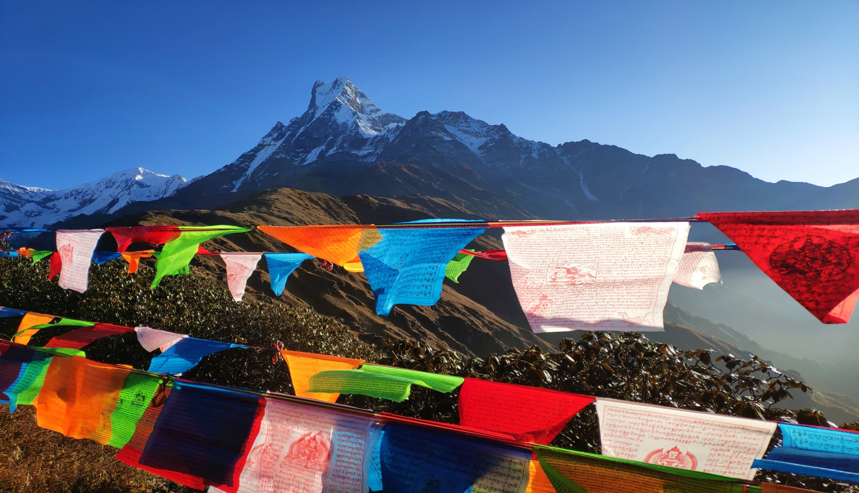

STTN 04 - Twin Valley Tour (05N/06D)
03N/KATHMANDU 02N/ POKHARA

Day 01 : Arrive in Kathmandu Upon arrival in Kathmandu Airport, you will be greeted and assisted by our Representative. After completing your custom formalities, transfer to Hotel for check-in. Afternoon, visit Boudhanath Stupa, Evening, attend aarati at Pashupatinath Temple. Drive back to Hotel. Overnight at Kathmandu Hotel.
Day 02 : Kathmandu - Via Manakamana Temple After breakfast, drive to Pokhara (about 210 km, 6/7 hrs). En-route visit Manakamana Temple by Cable Car . Continue to drive to Pokhara. Arrive in Pokhara. Transfer to Hotel. Overnight is at Hotel in Pokhara.
Day 03 : Pokhara Sighteeng & Sunrise Early morning, sunrise and Himalayan view from Sarangkot hill. Visit Bindabasini Temple. Drive to Hotel for breakfast. Later, visit Devis fall, Gupteshwor Cave, Seti River, and one hour boat ride on Phewa Lake and visit Taal Barahi Temple. Rest of the day is free. Overnight is at Hotel in Pokhara.
Day 04 : Pokhara- Kathmandu After having leisurely breakfast, drive towards Kathmandu. Upon arrive in Kathmandu, transfer to hotel for check in. Rest of the day is free. Overnight is at Kathmandu Hotel.
Day 05 : Kathmandu Sightseeing Breakfast is at Hotel. After breakfast, visit Jalanarayan Temple (Sleeping Vishnu). Next, visit Swoyambhunath Stupa and Kathmandu Durbar Square (Living God Kumari). Drive back to Hotel. Overnight is at Hotel in Kathmandu.
Day 06: Kathmandu - Departure After breakfast, the morning will be comparatively free and closer to the time of your flight, you will be transferred to the airport in time to board your flight for onward journey.
COST PER PERSON IN INR: (CP/BB – With B/ Breakfast Plan)
CATEGORY | 2-3 | 4-6 | 7-9 | 10-13 | 14-17 | 18-25 | 26-30 | 31-35
3 Star | 19,900 | 18,500 | 17,500 | 16,600 | 15,500 | 14,800 | 13,500 | 12,900
4 Star | 22,400 | 21,000 | 20,000 | 19,100 | 18,100 | 17,300 | 16,000 | 15,400
5 Star | 28,900 | 27,500 | 26,500 | 25,500 | 24,500 | 23,200 | 22,700 | 22,500

COST PER PERSON IN INR: (MAPAI – With B/ Breakfast & Dinner Plan)
CATEGORY | 2-3 | 4-6 | 7-9 | 10-13 | 14-17 | 18-25 | 26-30 | 31-35
3 Star | 21,400 | 20,000 | 19,000 | 18,100 | 17,000 | 16,300 | 15,000 | 14,400
4 Star | 24,900 | 23,500 | 22,500 | 21,900 | 20,600 | 19,800 | 18,500 | 17,900
5 Star | 34,900 | 32,500 | 31,500 | 30,500 | 29,300 | 28,000 | 27,500 | 27,300

COST PER PERSON IN INR: (APAI – With B/ Breakfast / Lunch & Dinner Plan )
CATEGORY | 2-3 | 4-6 | 7-9 | 10-13 | 14-17 | 18-25 | 26-30 | 31-35
3 Star | 22,900 | 21,500 | 20,500 | 19,600 | 18,500 | 17,800 | 16,500 | 15,900
4 Star | 27,400 | 26,000 | 25,000 | 24,400 | 23,100 | 22,300 | 21,000 | 20,400
5 Star | 39,500 | 37,500 | 36,500 | 35,500 | 34,300 | 33,000 | 32,500 | 32,300

INCLUSIONS & EXCLUSIONS
HOTELS USED
INDEX
OPTIONAL TOUR

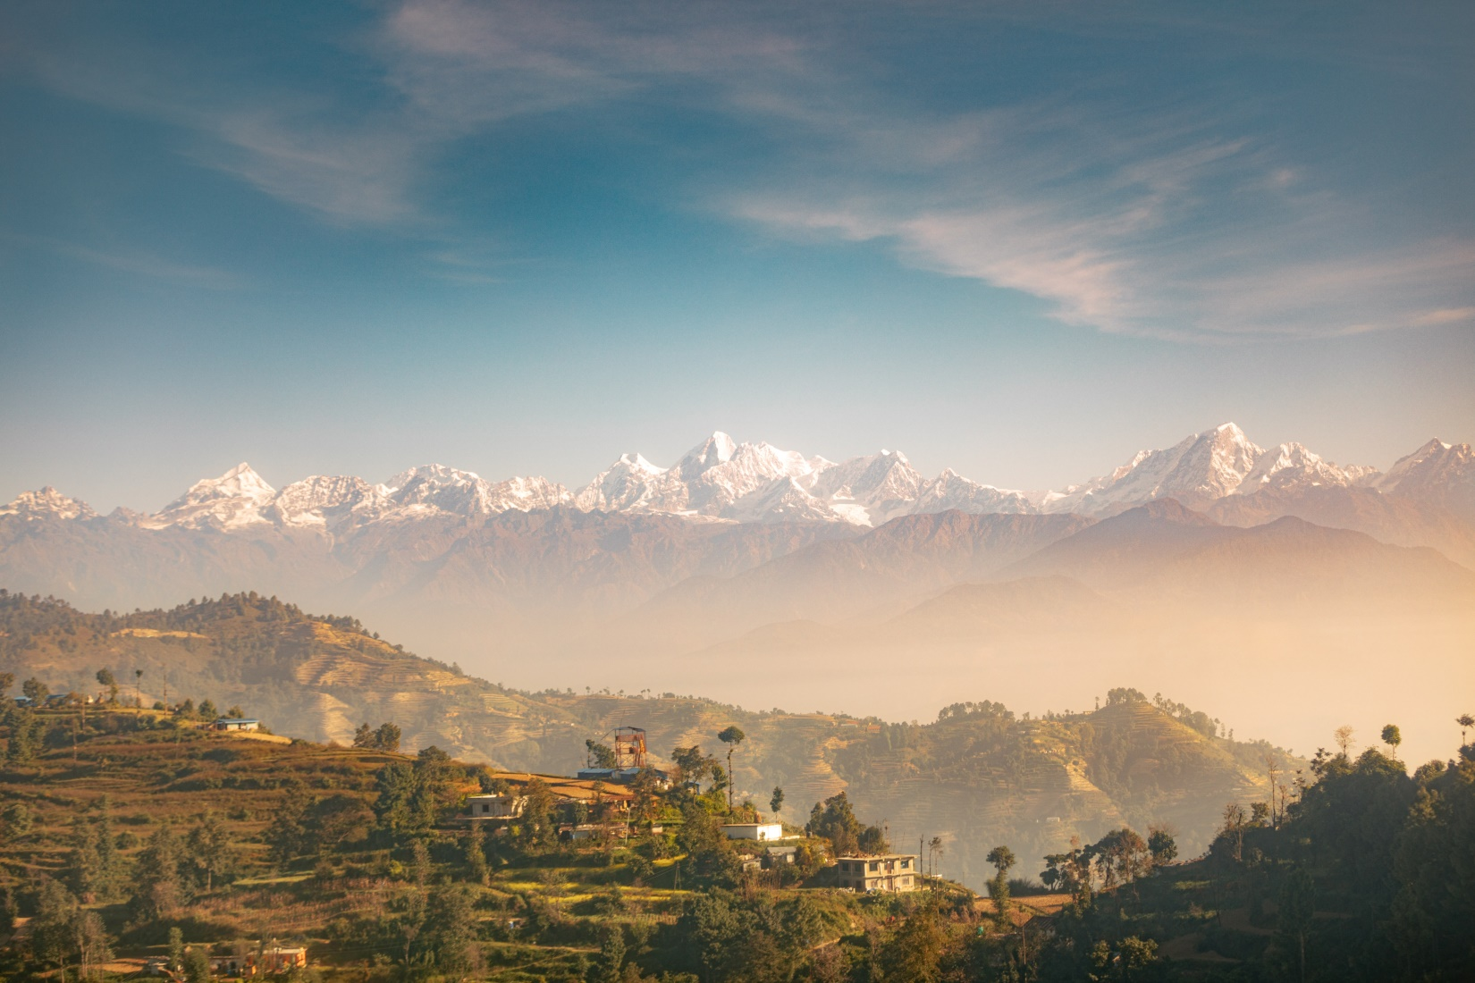

STTN 05 - Muktinath Yatra 06 Nights 07 Days
3N KATHAMNDU/2N POKHRA/1N JOMSOM
Day 01: Arrival – Kathmandu Upon arrival in Kathmandu Airport, you will be greeted and assisted by our Representative. After completing your custom formalities, transfer to your hotel. Evening, attend aarati in Pashupatinath Temple. Overnight is at Hotel in Kathmandu.
Day 02: Kathmandu – Pokhara After breakfast, drive to Pokhara (about 210 km, 6/7 hrs. drive). En-route, visit Manakamana Temple by Cable Car. After darshan, continue drive to Pokhara. Arrive in Pokhara. Transfer to Hotel. Evening, free time or stroll around Lake Side area. Overnight is at Hotel in Pokhara.
Day 03 : Pokhara - Jomsom (Fly 20 Minutes)-Muktinath Darshan After breakfast, fly to Jomsom (about 20 mints).Arrive in Jomsom Airport. Transfer to Hotel. Drive to Muktinath by Jeep (about 23 km, 1 hrs.’ drive). Take off from Jeep and walk up (30/40 mints) to Muktinath Temple. Arrive in Temple. Muktinath is god of Salvation. It holds great significance for all spiritual people in the south Asian sub-continent. Have darshan and worship, walk back to Jeep station and drive back to Jomsom. Overnight is at Hotel in Jomsom.
Day 04: Jomsom - Pokhar (Fly)- Pokhara Sightseeing Fly back to Pokhara.Arrive in Pokhara transfer to Hotel rest about 2 hours then sightseeing of Pokhara valley covering Devis water fall, Gupteshwor Mahadev Cave, Seti River George (white river) and Boating on Fewa Lake - visit Taal Barahi Temple. Overnight is at Hotel in Pokhara.
Day 05: Pokhara – Kathmandu After Breakfast at hotel drive back to Kathmandu by road it takes about (210 Km, 7-8 hours) having lunch on the way to Kathmandu.arrive at Kathmandu transfer to hotel check in. Overnight stay at Kathmandu.
Day 06: Kathmandu Sightseeing After breakfast, Visit Bouddhanath Stupa (world heritage site), Swayambhunath Stupa (Monkey Temple), Jalanarayan Temple, Patan Krishna Temple (Krishna Temple), drive back to Hotel. Overnight is at Hotel in Kathmandu.
Day 07: Kathmandu -Departure After breakfast, the morning will be comparatively free and closer to the time of your flight; you will be transferred to the airport to board your flight for onward journey.
COST PER PERSON IN INR: (CP/BB – With B/ Breakfast Plan)
CATEGORY | 2-3 | 4-6 | 7-9 | 10-13 | 14-17 | 18-25 | 26-30 | 31-35
3 Star | 36,500 | 34,500 | 32,500 | 30,500 | 29,500 | 29,000 | 28,500 | 27,500
4 Star | 38,700 | 36,700 | 34,700 | 32,700 | 31,900 | 31,200 | 30,700 | 29,700
5 Star | 46,000 | 44,000 | 42,000 | 40,000 | 39,000 | 38,500 | 38,000 | 37,000

COST PER PERSON IN INR: (MAPAI – With B/ Breakfast & Dinner Plan)
CATEGORY | 2-3 | 4-6 | 7-9 | 10-13 | 14-17 | 18-25 | 26-30 | 31-35
3 Star | 38,000 | 36,000 | 34,000 | 32,000 | 31,000 | 30,500 | 30,000 | 29,000
4 Star | 41,900 | 39,900 | 37,900 | 35,900 | 34,900 | 34,400 | 33,900 | 32,900
5 Star | 51,500 | 49,500 | 47,500 | 45,500 | 44,500 | 44,000 | 43,500 | 42,500

COST PER PERSON IN INR: (APAI – With B/ Breakfast / Lunch & Dinner Plan )
CATEGORY | 2-3 | 4-6 | 7-9 | 10-13 | 14-17 | 18-25 | 26-30 | 31-35
3 Star | 39,500 | 37,500 | 35,500 | 33,500 | 31,500 | 32,000 | 31,500 | 30,500
4 Star | 44,300 | 42,300 | 40,300 | 38,300 | 37,300 | 36,800 | 36,300 | 36,300
5 Star | 56,500 | 54,500 | 52,500 | 50,500 | 49,500 | 49,000 | 48,500 | 47,500

INCLUSIONS & EXCLUSIONS
HOTELS USED
INDEX
OPTIONAL TOUR

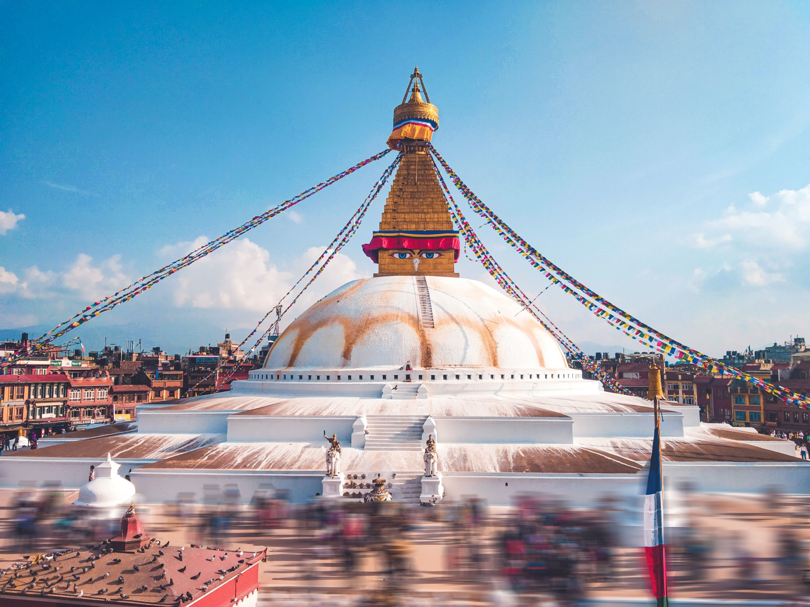

STTN 06 - Triangle Nepal Tour (06Nights /07 Days)
2N/ Kathmandu, 2N/ Pokhara, 2NChitwan

Day 01 : Gorakhpur – Pokhara(about 300 km, 8/9 hrs drive Pickup from Gorakhpur drive to Lumbini for sightseeing of Mayadevi Temple, Ashoka pillar and sacred pond. Later, continue drive to Pokhara. Overnight in Pokhara Hotel.
Day 02:Sarangkot Excursion & Sightseeing Early morning, sunrise and Himalayan view from Sarangkot hill (Subject to weather condition). Next, Visit Bindabasini Temple. Drive to Hotel for breakfast. Later, visit Devis fall, Gupteshwor Cave, Seti River, and one hour boat ride on Phewa Lake and visit Taal Barahi Temple. Overnight in Pokhara Hotel.
Day 03 : Pokhara – Kathmandu drive Via Manakamana Temple Early morning after breakfast, drive back to Kathmandu(210 km, 6/7hrs drive). En-route visit Manakamana Devi temple.After darsan, continue drive back to Kathmandu and transfer to Hotel.Overnight at Hotel in Kathmandu.
Day 04 : Kathmandu sightseeing After Breakfast, sightseeing tour of Pashupatinath Temple Jala Narayan Temple( Sleeping Vishnu ) and Swoyambhunath Stupa ( Monkey Temple),Bouddhanath Stupa. Overnight at Hotel in Kathmandu.
Day 05 : Kathmandu – Chitwan Drive to Chitwan (about 175 km, 7/8 hrs drive). Arrive in Chitwan. Transfer to Hotel for check –in. Upon arrival, lunch will be served. After that, visit Tharu Village. Evening, sunset and Tharu Stick Dance. Dinner and overnight is at Hotel in Chitwan.
Day 06: Chitwan Activities Today, you will enjoy Jungle activities like, Elephant back safari, Elephant Breeding Center, Canoe ride on the Rapti River, Jungle Walk and Elephant bath (during summer season only). Overnight is at Hotel in Chitwan.
Day 07: Gorakhpur -Departure After breakfast, the morning will be comparatively free and closer to the time of your flight,you will be transferred to the airport to board your flight for onward journey.
COST PER PERSON IN INR: (CP/BB – With B/ Breakfast Plan)
CATEGORY | 2-3 | 4-6 | 7-9 | 10-13 | 14-17 | 18-25 | 26-30 | 31-35
3 Star | 27,500 | 25,500 | 23,500 | 22,900 | 22,500 | 21,500 | 20,500 | 19,800
4 Star | 30,500 | 28,500 | 26,500 | 25,900 | 25,500 | 24,500 | 23,500 | 22,800
5 Star | 36,500 | 34,500 | 33,500 | 31,900 | 31,500 | 30,500 | 30,000 | 29,500

COST PER PERSON IN INR: (MAPAI – With B/ Breakfast & Dinner Plan)
CATEGORY | 2-3 | 4-6 | 7-9 | 10-13 | 14-17 | 18-25 | 26-30 | 31-35
3 Star | 28,700 | 26,700 | 27,700 | 24,100 | 23,700 | 22,700 | 21,700 | 21,000
4 Star | 32,900 | 30,900 | 28,900 | 28,300 | 26,700 | 25,700 | 24,700 | 25,200
5 Star | 40,500 | 38,500 | 37,500 | 35,900 | 35,500 | 34,500 | 34,000 | 33,500

COST PER PERSON IN INR: (APAI – With B/ Breakfast / Lunch & Dinner Plan )
CATEGORY | 2-3 | 4-6 | 7-9 | 10-13 | 14-17 | 18-25 | 26-30 | 31-35
3 Star | 29,900 | 27,900 | 28,900 | 25,300 | 24,900 | 23,900 | 22,900 | 22,200
4 Star | 35,300 | 32,900 | 31,300 | 30,700 | 29,100 | 28,100 | 27,100 | 26,400
5 Star | 44,500 | 42,500 | 41,500 | 39,900 | 39,500 | 38,500 | 38,000 | 37,500

INCLUSIONS & EXCLUSIONS
HOTELS USED
INDEX
OPTIONAL TOUR
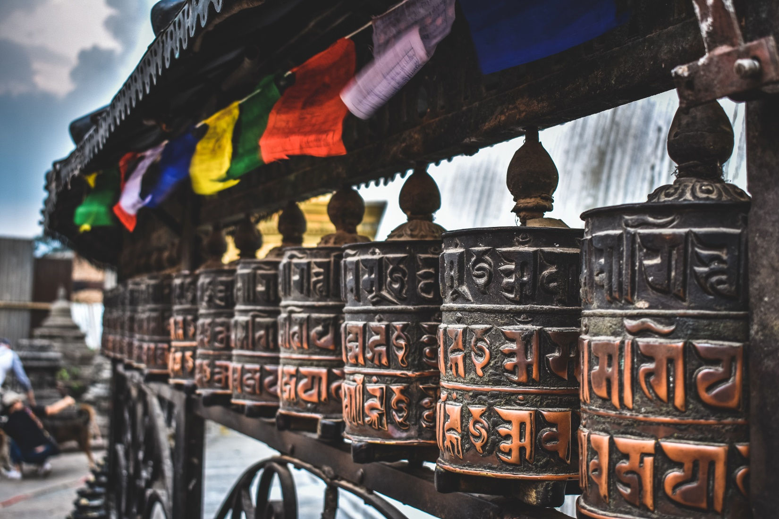

STTN 07 - Nepal Triangle Tour (07 Nights/08 Days)
3N/ Kathmandu, 2N/ Pokhara ,2NChitwan

Day 01 : Arrive in Kathmandu Upon arrival in Kathmandu Airport,you will be greeted and assisted by our representative. After completing your custom formalities, transfer to the Hotel for check-in. Afternoon, visit Boudhanath Stupa, Evening, attend aarati at Pashupatinath Temple,drive back to Hotel. Overnight at Kathmandu Hotel.
Day 02 : Kathmandu Sightseeing After breakfast,Sightseeing of Kathmandu Valley Including Jalanarayan (Sleeping Vishnu) Swayambhunath (Monkey Temple),Kathmandu Durbar Squire (Living God Kumari) and Bhaktapur Durbar Square (Shooting Sport & World heritage site) back to Hotel. Overnight is at a Hotel in Kathmandu. Note : Mount Everest flight can be arrange on your request.
Day 03 : Kathmandu - Pokhara via Manakamana Temple After breakfast, drive to Pokhara (about 210 km, 6/7 hrs). En-route visit Manakamana Temple by Cable Car .Continue to drive to Pokhara.arrive in Pokhara. Transfer to Hotel. Rest of the day is free for stroll around the surrounding Lakeside Pokhara night market. Overnight at a Hotel in Pokhara.
Day 04 : Sarangkot Excursion & Sightseeing Early morning 5 Am sunrise and Himalayan view from Sarangkot hill (subject to weather condition). Visit Bindabasini Temple. Drive to the Hotel for breakfast. Later, visit Davis water fall, Gupteshwor Cave, Seti River, and one hour boat ride on Phewa Lake and visit Taal Barahi Temple. Rest of the day is free. Overnight at a Hotel in Pokhara.
Day 05 : Pokhara – Chitwan After breakfast at 7 Am drive to Chitwan (about 150 km, 5 hrs drive). Arrive in Chitwan. Transfer to Hotel for check –in. Upon arrival, lunch will be served. After that, visit Tharu Village. Evening, sunset and Tharu Stick Dance. Overnight at a Hotel in Chitwan.
Day 06: Chitwan Activities Today, you will enjoy Canoe ride on the Rapti River (Crocodile watching) ,Elephant Breeding Center, Jungle Walk and Elephant bath (during summer season only) then come back for lunch and rest the Evening Elephant Back Safari at National Park. Overnight at a Hotel in Chitwan.
Day 07: Chitwan- Kathmandu After breakfast, drive back to Kathmandu.Upon arrival in Kathmandu transfer to the Hotel for check-in later you are free for shopping at Thamel Tourist night market. Overnight is at a Hotel in Kathmandu.
Meals : Breakfast & Dinner at Hotels and Lunch on the way to Kathmandu.
Day 08: Kathmandu - Departure After breakfast, the morning will be comparatively free and closer to the time of your flight, you will be transferred to the airport in time to board your flight for onward journey.

COST PER PERSON IN INR: (CP/BB – With B/ Breakfast Plan)
CATEGORY | 2-3 | 4-6 | 7-9 | 10-13 | 14-17 | 18-25 | 26-30 | 31-35
3 Star | 27,500 | 25,500 | 24,500 | 24,000 | 23,400 | 23,000 | 22,000 | 20,500
4 Star | 31,000 | 29,000 | 28,000 | 27,500 | 26,500 | 25,500 | 24,500 | 23,000
5 Star | 37,500 | 37,500 | 36,500 | 35,500 | 35,000 | 34,000 | 33,500 | 33,000

COST PER PERSON IN INR: (MAPAI – With B/ Breakfast & Dinner Plan)
CATEGORY | 2-3 | 4-6 | 7-9 | 10-13 | 14-17 | 18-25 | 26-30 | 31-35
3 Star | 29,000 | 27,000 | 26,000 | 25,500 | 24,900 | 24,500 | 23,500 | 21,500
4 Star | 34,000 | 32,000 | 31,000 | 30,500 | 29,500 | 28,500 | 27,500 | 26,000
5 Star | 44,500 | 42,500 | 41,500 | 40,500 | 40,000 | 39,000 | 38,500 | 38,000

COST PER PERSON IN INR: (APAI – With B/ Breakfast / Lunch & Dinner Plan )
CATEGORY | 2-3 | 4-6 | 7-9 | 10-13 | 14-17 | 18-25 | 26-30 | 31-35
3 Star | 30,500 | 29,500 | 28,500 | 27,000 | 26,400 | 26,000 | 25,000 | 23,000
4 Star | 37,000 | 35,000 | 34,000 | 33,500 | 32,500 | 31,500 | 30,500 | 29,000
5 Star | 48,500 | 47,500 | 48,500 | 45,500 | 45,000 | 44,000 | 43,500 | 43,000
INCLUSIONS & EXCLUSIONS
HOTELS USED
INDEX
OPTIONAL TOUR

STTN 08 - Classical Nepal Tour (08 Nights / 09 Days)
3N/ Kathmandu, 2N/ Pokhara , 1N Lumbini & 2N/ Chitwan

Day 01 : Arrive in Kathmandu Upon arrival in Kathmandu Airport, you will be greeted and assisted by our Representative. After completing your custom formalities, transfer to the Hotel for check-in. Afternoon, visit Boudhanath Stupa, Evening, attend Aarati at Pashupatinath Temple. Drive back to Hotel. Overnight at Kathmandu Hotel.
Day 02 : Kathmandu - Pokhara Via manakamana Temple After breakfast, Darshan of Pasupatinath Temple, drive to Pokhara (about 210 km, 6/7 hrs). En-route visit Manakamana Temple by Cable Car .Continue to drive to Pokhara.Arrive in Pokhara. Transfer to Hotel. Rest of the day is free for stroll around the surrounding area. Overnight at a Hotel in Pokhara.
Day 03: Sarangkot Excursion & Sightseeing Early morning 5 Am sunrise and Himalayan view from Sarangkot hill (subject to weather condition). Visit Bindabasini Temple. Drive to the Hotel for breakfast. Later, visit Davis water fall, Gupteshwor Cave, Seti River, and one hour boat ride on Phewa Lake and visit Taal Barahi Temple. Rest of the day is free. Overnight at a Hotel in Pokhara.
Day 04 : Pokhara - Lumbini Drive to Lumbini (about 180 km, 6/7hrs drive). Arrive in Lumbini. Transfer to Hotel then Visit Mayadevi Temple(birth Place Buddha) Later visit Stupas and Monastery . Overnight is at the Hotel in Lumbini.
Day 05 : Lumbini - Chitwan Drive to Chitwan (about 120 km, 4 hrs drive).Arrive in Chitwan. Transfer to Hotel for check –in. Upon arrival, lunch will be served. After that, visit Tharu Village. Evening, sunset and Tharu Stick Dance. Overnight at a Hotel in Chitwan.
Day 06: Chitwan Activities Today, you will enjoy Canoe ride on the Rapti River (Crocodile watching) ,Elephant Breeding Center, Jungle Walk and Elephant bath (during summer season only) then come back for lunch and rest the Evening Elephant Back Safari at National Park. Overnight at a Hotel in Chitwan.
Day 07: Chitwan- Kathmandu After breakfast, Elephant Safari then drives back to Kathmandu. Upon arrival in Kathmandu, visit Swoyambhunath Stupa (Monkey Temple). Later, transfer to Hotel for check-in. Overnight is at a Hotel in Kathmandu.
Day 08: Kathmandu – Sightseeing After breakfast, Sightseeing of Kathmandu Valley Including Bouddhanath Stupa,JalaNarayan Temple(Sleeping Vishnu),Swayambhunath Stupa (Monkey Temple),Kathmandu Durbar Square (Living God Kumari) back to Hotel. Overnight is at a Hotel in Kathmandu.
Day 09 : Kathmandu - Departure After breakfast, the morning will be comparatively free and closer to the time of your flight, you will be transferred to the airport in time to board your flight for onward journey.
COST PER PERSON IN INR: (CP/BB – With B/ Breakfast Plan)
CATEGORY | 2-3 | 4-6 | 7-9 | 10-13 | 14-17 | 18-25 | 26-30 | 31-35
3 Star | 31,900 | 29,700 | 27,500 | 26,400 | 25,800 | 25,200 | 24,400 | 22,700
4 Star | 35,300 | 32,800 | 31,300 | 30,500 | 29,500 | 28,500 | 27,500 | 64,000
5 Star | 45,000 | 42,500 | 41,000 | 40,200 | 39,000 | 38,000 | 37,500 | 75,000

COST PER PERSON IN INR: (MAPAI – With B/ Breakfast & Dinner Plan)
CATEGORY | 2-3 | 4-6 | 7-9 | 10-13 | 14-17 | 18-25 | 26-30 | 31-35
3 Star | 33,700 | 31,500 | 29,500 | 28,500 | 27,600 | 27,000 | 26,200 | 24,500
4 Star | 38,900 | 36,400 | 34,900 | 34,100 | 33,100 | 32,100 | 31,100 | 29,600
5 Star | 51,000 | 48,500 | 47,000 | 46,200 | 45,000 | 44,000 | 43,500 | 43,000

COST PER PERSON IN INR: (APAI – With B/ Breakfast / Lunch & Dinner Plan )
CATEGORY | 2-3 | 4-6 | 7-9 | 10-13 | 14-17 | 18-25 | 26-30 | 31-35
3 Star | 35,500 | 33,500 | 31,300 | 30,300 | 29,400 | 28,800 | 28,000 | 26,300
4 Star | 42,500 | 40,000 | 38,500 | 37,700 | 36,700 | 35700 | 34,700 | 33,200
5 Star | 57,000 | 54,500 | 53,000 | 52,200 | 51,000 | 50,000 | 49,500 | 49,000
INCLUSIONS & EXCLUSIONS
HOTELS USED
INDEX
OPTIONAL TOUR

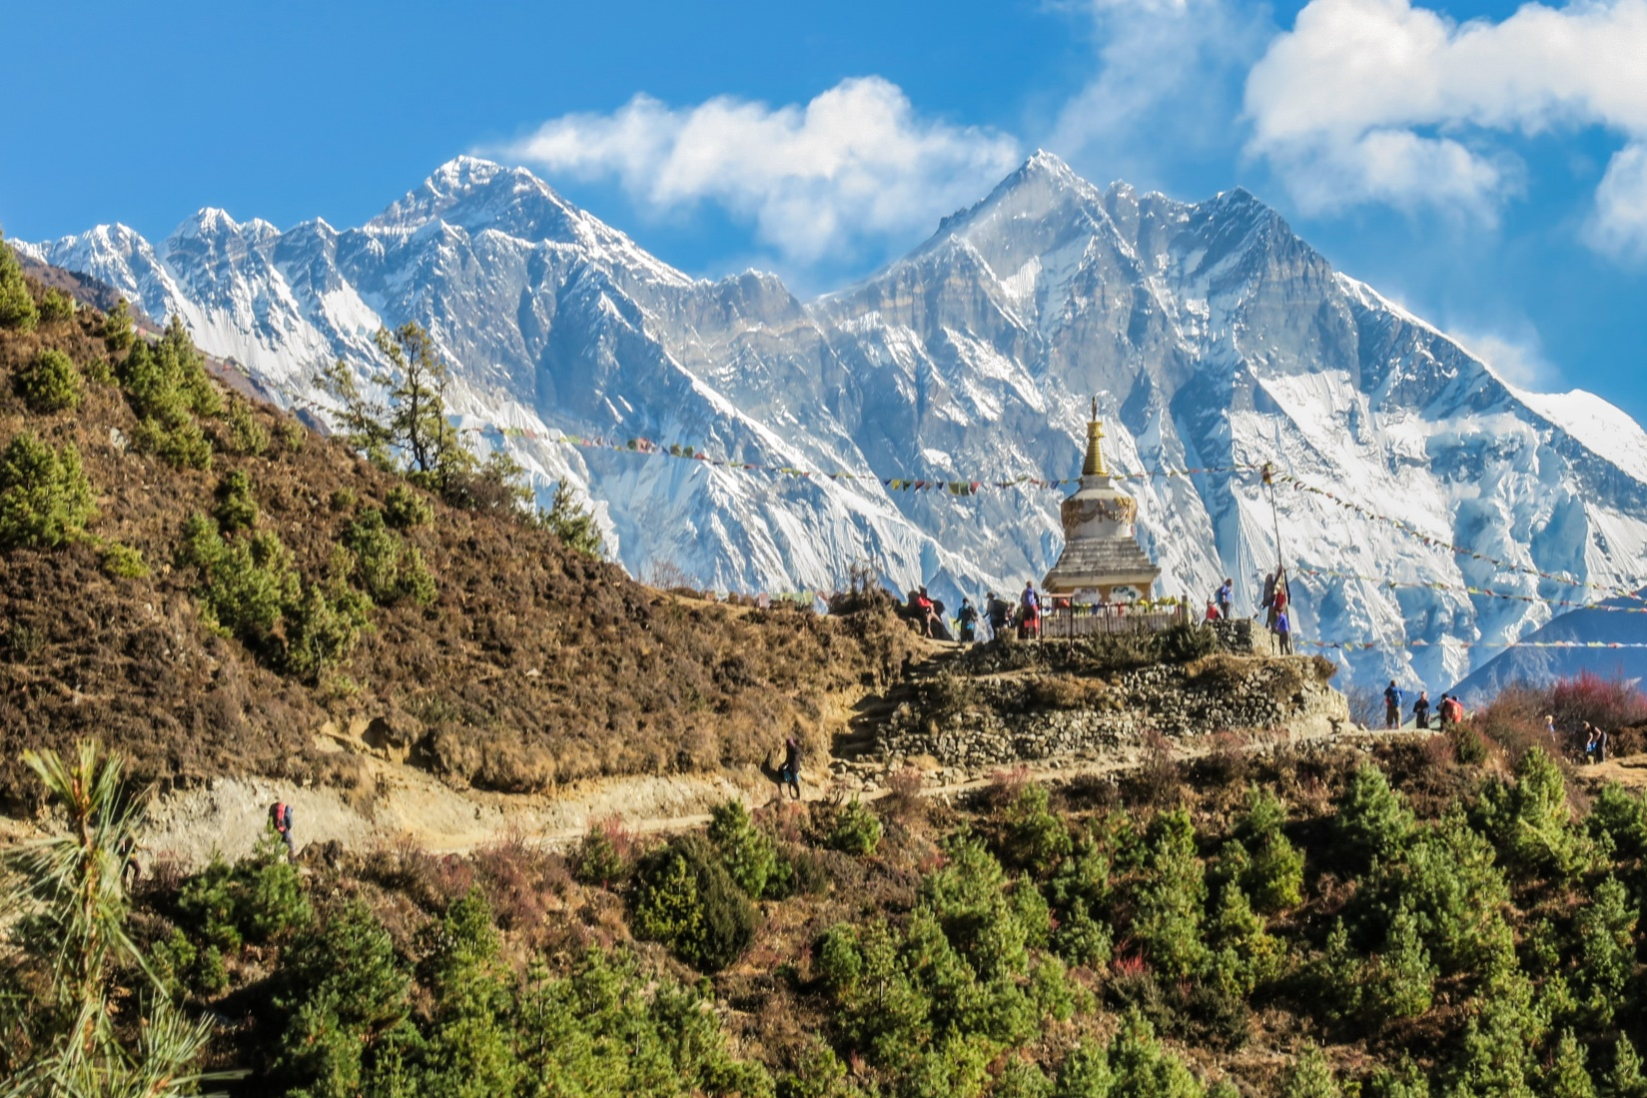
OPTIONAL TOURS AT ADDITIONAL COST

Adventure activities in Pokhara : White rafting ,Paragliding ,Bungee jumping ,Zip flyer , Altra flight ,Hot Air balloon, ABC Helicopter ride on own Cost

OPTIONAL TOUR
S.N. | PARTICULARS | OTHER PP HOLDER | INDIAN PP HOLDER
1. | MOUNTAIN FLIGHT | US $ 262 | INR 9500
2. | PARAGLIDING | US $ 100 | INR 5000
3. | BUNZY JUMPING | US $ 70 | INR 4500
4. | ZIP LINE | US $ 70 | INR 4500
5. | CULTURAL DINNER | US $ 20 | INR 1000
6. | MANAKAMANA CABLE CAR | US $ 20 | INR 625

Note: Above rate is including optional tour cost with transport facility. These tours can be accommodated in all above designed itineraries.

HOTELS USED IN THE PACKAGE
CITY | 3 STAR | 4 STAR | 5 STAR
Kathmandu | Hotel Apsara Boutique/Hotel Taps / Hotel Arts / Similar | Hotel Grand/Hotel Akama/ Similar | Hotel Shangrila/Hotel Aloft Similar
Pokhara | Hotel Batika/Kuti Resort | Hotel Grand / Water front Resort/Similar | Temple Tree Resort/ Similar
Jomsom | Hotel Trekkers Inn(Non Star) | Hotel Oms Home(Non Star) | Hotel Oms Home(Non Star)
Chitwan | Center Park Resort/ Similar | Landmark forest Park/ Similar | Hotel Green park/ Similar
Lumbini | Hotel Mourya/Similar | Buddha Maya Garden/ Similar | Tiger Place Resort/Similar

INDEX

INCLUSIONS & EXCLUSIONS
PACKAGE COST INCLUDES
- Welcome drink on arrival (Non-alcoholic)
- Traditional wwelcome on aarrival.
- Assistant Guide in arrival and departures / Hotels.
- Hotel Accommodation on double sharing basis.
- Accommodation in respective hotel’on mention basis.
- Vehicles are not to be at disposal and are available as per itinerary only (point to point basis).
- All sightseeing and excursions as mentioned in the itinerary by private Air condition vehicle.
- All vehicle parking fees at the attractions.
- Mineral water serve during trip
- Transport Kathmandu to Kathmandu by private basis in A/C vehicle.
- All Applicable Taxes.

PACKAGE COST EXCLUDES
- International Flight Airfare & Train fares.
- Entrance fees.
- Expenses due to the situation beyond our control (Such as; landslides, natural calamities, road blockade, political disturbance, flight cancellation etc.)
- Expenses of personal Nature.
- Medical expenses.
- Manakamana Cable Car tickets.
- Boat ride fee on Phewa Lake.
- Monuments entrance fees as applicable & payable fee on the spot.
- Other Services not mentioned in cost including.
- Personal Insurances
Note: Voter Card or Passport is mandatory for Indian air passengers
INDEX

ACCOUNT DETAILS
SHAH TOURS AND TRAVELS
ACCOUNT NO: 055263400002230
(IFSC CODE: YESB 0000552) YES BANK, SEVOK ROAD, SILIGURI.

We do hope that you find all in order, thanking you & us assuring our best services at all time.
For any further clarification, please feel free to contact us any time.

Thanks & Regards.

Ajay Shah
B - 56, Satellite Township, ,Dabgram, Siliguri. 734015,
Mobile : 99320 31500 / 94341 31500
E-mail : shahtours2001@yahoo.com, info@shahtour.com, Web: www.shahtour.com
Contact us for : Domestic & International Air Tickets / Hotel Reservation / Car Rental .
Domestic and International / Packages / LTC Packages.
24 HOURS HELPLINE : 09932031500 / 934131500 , 21 YEARS OF EXCELLENCE IN ALL TRAVEL RELATED SERVICES.
Our Services: Car Rental | Tour packages | Honeymoon packages, Air tickets | Chardham Yatra -2018 | Amarnath Yatra -2018| Holiday Packages | Himachal | Uttaranchal |Rajasthan | Kerala | Goa | Kashmir | Golden Triangle tours| School, College and Corporate Group tours | and many more.

